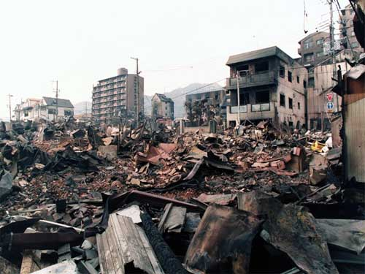

Jason Siwek

Lauren Norman

Henry Trimbach

Heather Moulton  
Roger Williams University  
May 18, 2011  
RWU.HOME.2010@gmail.com

**H.O.M.E.**

# Abstract

In the aftermath of disaster, many people are left without shelter or basic living necessities. According to international law, it is the responsibility of a country to provide housing for these internally displaced people. However, the cause of displacement often compromises the authority of the government or their ability to provide aid. In this case, it falls to outside organizations to provide shelter from the elements. Current shelters fall into three categories: emergency, transitional, and permanent. The goal of the Human Occupied Modular Environment (HOME) project is to create a structure which will fill the gap between emergency and transitional shelter as well as provide basic living necessities. It must also be a viable commercial product and be fabricated at a low cost. To differentiate the HOME from existing structures, it will be as sturdy and long-lasting as transitional shelter but be quick and simple in assembly so that it can be used in for the rapid response of an emergency. Typical transitional shelter must be set up by skilled laborers, which means that it can take days to weeks to assemble. The HOME will have the ability to be set up by two to three people without using power tools or instruction manuals. To further simplify this assembly process, HOME will be created with the fewest number of unique parts possible. The door will be the only moving part included in the design, which will eliminate any failure modes associated with friction or wear over time. Systems considered for the design include shelter, power, water, ventilation, and personal storage. All UN Shelter Centre guidelines concerning sustainability, usability, and environmental safety and health factors will be followed. The primary focus of this project was on the water filtration and power production of the HOME. The design process began with specifying the goals and design requirements of each system. In-depth research on options for each system was then completed. Testing and analysis of each of these options based on their ability to fit the requirements was done and the lists were narrowed down. For water collection different roof panel designs were considered and the final design will have glides to divert rainwater to a common collection point. For water filtration activated carbon, reverse osmosis and bio sand filters were considered. The final filtration will incorporate self-cleaning mesh, a first flush diverter and a settling tank. The different forms of power production considered were human, solar, fuel cells and wind. The power will be generated by completely off-the-grid, entirely renewable and sustainable sources. To accomplish this, the primary source of generation will be a human mechanism supported by solar panels. A great deal of research was done to design a solar array for maximum efficiency for all locations of use. The human power mechanism will be compact and adjustable so that both adults and children can contribute to the power generation. The next step in the project will be the completion of design of human waste system and food growth. Structural analysis will be done on the entire structure and connection points. The components involved with power storage as well as wiring selection will be selected and designed. Finally reliability testing of the materials and the electronic components will be done.

# Contents

……………………………………………………………………………………… 4

……………………………………………………………………………………………….. 5

………………………………………………………………………..…. 7

………………………………………………..… 7

……………………………………………….... 8

……………………………………………………...... 8

…………………………………………………………. 9

……………………………………………………………………………. 11

………………………………………………………….. 12

……………………………………………………………...………. 12

………………………………………………………… 14

………………………………………………………………..…………….. 15

………………………………………………………………….. 16

…………………………………………………………..…………. 17

…………………………………………………………………………… 18

……………………………………………………………………. 19

………………………………………………...…………………………. 20

……………………………………………………………………………. 23

………………………………………………………………….. 25

Design By Region……………………………………………………………………. 27

………………………..……………………………………. 29

………………………………………………………………………. 31

……………………………………………………………. 32

………………………………………………………………………………………. 32

…………………………………………………………………………………. 32

………………………………………………………………………………………. 33

……………………………………………………………………………………. 33

…………………………………………………………………… 34

……………………………………………………………………………………… 34

…………………………………………………………………………………… 39

………………………………………………………………………….. 41

……………………………………………………………… 42

…………………………………………………………………………………………… 43

……………………………………………………………… 43

………………………………………………………………………………………. 45

…………………………………………………………………………. 48

………………………………………………………………………………………. 49

……………………………………………………………………………………….. 49

………………………………………………………………………………. 50

………………………………………………………………………………………………….. 52

…………………………………………………………………………………….. 54

………………………………………………………………………………………….. 55

# Executive Summary

In recent times, there has been an increase in the need for temporary shelters for people displaced by disasters. Their priority in times like these is to find shelter, which is often provided by international organizations. The simplest and most efficient form of shelter is often referred to as emergency shelter. Typically tents, traps or plastic sheets, the speed and ease with which these can be assembled makes them ideal for immediate relief from the elements for the displaced persons. However, in order for these shelters to be quick to assemble, the material is not strong enough to withstand harsh weather or long periods of time. The next level of shelter is transitional shelter which is more durable and can stand up to the elements. It can also be used for years at a time. However, in using stronger material, the setup time increases. There are also permanent shelters available which are the most durable emergency housing, but they take months to build and are not a feasible solution for the immediate shelter that the displaced persons need.

In order to provide the ideal temporary shelter, the best aspects of each of the current options must be considered. It would have the quick assembly of emergency shelters, the durability and longevity of transitional shelters, and the amenities available in permanent shelters. The Human Occupied Modular Environment (H.O.M.E.) combines all of these features. With wall, floor, and roof panels that snap together, along with a power cap and column assembly that fits into place, assembly is simple, fast, and requires no tools. Stringers in the joints between the durable plastic panels offer extra strength and load distribution. The H.O.M.E. will offer water containment and filtration, power generation for lights and an outlet, ventilation, a human waste removal system, and food production. There will be sleeping space for up to four people, as well as seating, a table, and storage. The versatility of the H.O.M.E. will allow connecting the shelters together in order to accommodate larger groups of people. There will also be as few unique pieces as possible in order to facilitate production and assembly.

The creation of such a product requires a large team. The leader and originator of this project is Rick Davids. Two teams have been formed in order to continue the design and perform analysis. These two teams are a team from Roger Williams University and a team from University of Rhode Island. The Roger Williams team is taking on the power and water designs, while the University of Rhode Island team is in charge of the structural component. Both teams will be working together to finalize design choices and run analyses.

While these shelters will be used by displaced persons, they must be sold to the organizations providing the shelters. The shelters must comply with certain regulations from organizations such as United Nations and the World Health Organization in order to be useable by disaster relief groups. Some of these regulations are the requirement of two exit points, the acceptable quality of drinking water, and the color of the H.O.M.E., which must be either white or blue. The ultimate goal is to make the H.O.M.E. commercially available for use by campers and groups such as the Boy Scouts for recreational use. While this is not the primary concern, it must be considered during the entire design process.

Compared to other shelters currently on the market, the HOME will be more desirable because of the amenities provided with such a short setup time. While emergency shelters have a quick setup, they are not made of strong enough materials to withstand harsh weather or long periods of time.

The goal is to be able to sell this product within the range of $10000 to $12000. There will be different options available at different costs depending on what amenities the client wants the H.O.M.E. to have and how much the client is able to spend.

# Introduction

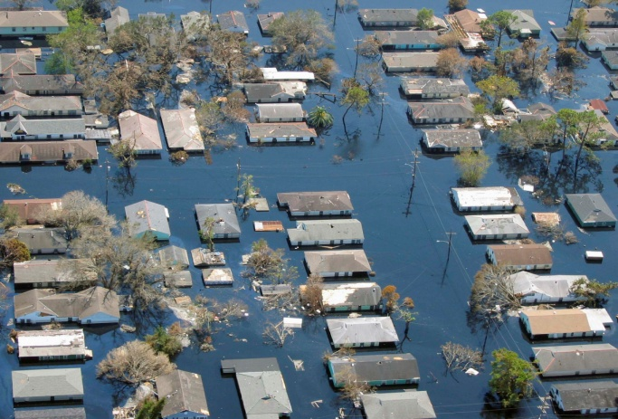The Human Occupied Modular Environment project, or HOME, seeks to provide a low-cost alternative to disaster relief housing currently available on the market. It will be simple to set up, durable, long-lasting, made of renewable materials, and will take human factors into account. It will house three to four people, and will be modular such that units may be combined to accommodate larger families.

***Figure 1:*** *Aftermath of Hurricane Katrina. Shelter for the displaced peoples is still a work in progress.*

An internally displaced person is someone who is forced to flee his or her home because of some type of disaster. In 2005, there were an estimated twenty-five million internally displaced persons. Seventy percent were women and children. These people need immediate shelter from the elements. Unlike a refugee, an IDP remains within his or her country's borders, and International law states that this country is responsible for providing for its own displaced persons. However, the disaster that has forced people from their homes can also make it impossible for their country to provide for them. The disaster may be so widespread and debilitating that the government doesn’t possess the resources to help its people. The disaster may also be political, which may put the authority of the government in question, preventing it from mobilizing any substantial response to the displacement of its people.

As a result, it often falls to outside organizations to provide for internally displaced persons. While the responsibility of providing for refugees belongs to the United Nations High Commissioner on Refugees, there is no such centralized authority for internally displaced persons. The UNHCR has, however, agreed to “assume the lead responsibility for protection, emergency shelter and camp management for internally displaced people.” The overall approach is collaborative, including UN agencies such as the UNHCR, UNICEF, the World Food Programme, the United Nations Development Programme, the International Committee of the Red Cross, and others. Different organizations are responsible for different aspects of IDP aid, where emergency shelter is provided primarily by the International Federation of Red Cross.

There are three major categories of shelter that are provided for displaced peoples. Emergency shelter consists of tents, tarps, plastic sheeting, and/or corrugated roofing. It is quick to set up, but provides meager amenities and lasts from a few a months to a few years. Transitional housing usually consists of a more rigid structure made of wood, concrete, steel, block, or brick. It provides better protection from the elements and a more long-lasting structure, but takes more time and resources to set up. Finally, permanent shelter provides a rigid floor, walls, and roof, like the structures created by Habitat for Humanity. It is often better than pre-disaster housing.

There is a clear need for housing that can provide some of the benefits of transitional shelter while remaining as easy and fast to set up as emergency shelter. The primary objectives of this design will be ease and speed of setup characteristic of emergency shelter, such that it may be assembled by the displaced peoples themselves; the longevity and protection associated with transitional shelter; and provisions for human needs like water, power, and food.

# Analysis of Problem

The problem of improving on existing housing solutions for displaced peoples can be broken down into four main categories. First, the new design must offer the primary benefits of emergency housing: speed and ease of setup. Second, it must also offer the primary benefits of transitional housing: protection and relative longevity. Third, it must better provide for human needs such as clean water and electricity. Fourth, it must be a commercially viable design.

## Characteristics of Emergency Shelter

The main benefits of emergency shelter are the ease of setup, shipping, and portability. These characteristics allow emergency shelter to fill its role as a rapid-response solution for displaced peoples. The new design must be effective as an immediate reaction to a disaster situation. It must be easy to ship and distribute, and it must not require skilled labor to be deployed. Ideally, the shelters should be able to be installed by the displaced peoples themselves, so as to facilitate a rapid installation.

***Figure 2:*** *Emergency shelter is most typified by the use of tents which are quick and easy to set up but do not provide strong housing in a structural sense.*

The design should be self-contained, to make shipping as easy as possible. If necessary, it should be transportable in multiple pieces, so that it might be carried by two people. The pieces must also not be so heavy that two people can’t easily carry them. It also should be possible for the structure to be disassembled and moved if necessary.

The fact that the structure will be used by diverse populations of people in countries around the globe poses a particular challenge for the ease of setup requirement. Because skilled laborers will not be installing the structures, there must be simple and minimal instructions. Assembly must be intuitive, and whatever instructions are required must not have any language requirement. Simple pictorial instructions must suffice for assembly.

Furthermore, assembly must not require tools. Loose fasteners or small pieces should not be used, because they might be lost and render installation impossible. Any lifting required must be manageable by a 50th percentile adult, as bigger, stronger people may not be available.

## Characteristics of Transitional Shelter

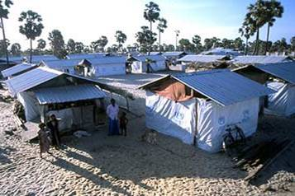The main benefits of transitional shelter are longevity and better protection from the elements. These shelters are used to house displaced peoples before permanent housing can be acquired. However, before transitional shelter can be established, displaced peoples are forced to live in their meager emergency accommodations, sometimes for far too long. The new design will bring some of the benefits of transitional shelter much more rapidly.

***Figure 3:*** *Example of transitional housing; made with boards and corrugated roofing.*

The structure should last for three to five

years in order to approach the longevity of transitional housing. Structural materials must survive for the lifespan of the structure. Moving parts must be minimized to eliminate the danger of their wearing out. All subsystems must survive the lifespan without failing with minimal maintenance. Reliability for the entire system should be 95%.

The structure must also provide protection against the elements in varying climates. It must allow protection from heavy rainfall and snow. It must shield occupants from the sun and wind. It must protect against insects and vermin. It must also provide protection from heat and cold. Additionally, it should withstand and protect from seismic events.

## Consideration of Human Factors

The structure will also provide for numerous human needs better than existing emergency and transitional shelter options. These needs include water storage and filtration, electricity, storage and special accommodations, food, waste management, and privacy. These factors are key motivators in the design, as they set it apart from existing solutions and dramatically improve quality of life for displaced peoples.

Clean water is essential for comfortable and healthy human life. The structure will collect rainwater in any areas where it is feasible. It must collect and store enough water to satisfy minimum water usage requirements for three to four people for a week, or about 80 gallons. The water system must contain filtration methods to ensure clean water. Rain water must be filtered for pH, particulates, and microbes. The storage must also exclude sunlight to prevent algae growth.

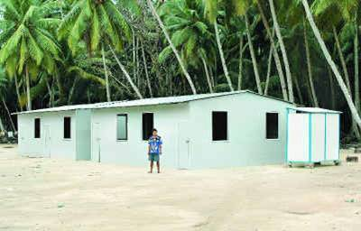The structure will also provide electricity for essentials such as lighting and charging for cellular phones and laptop computers. The lighting must be bright enough to enable activities like reading, but not so bright as to annoy occupants that are trying to rest or relax. Because natural light may be limited, lights must be able to be run for 12 hours per day. A laptop will require a 50 W outlet, which will be able to be run for 5 hours per day. Additionally, the power source must be renewable and self-contained, such that it may be available at all times and in any location, and each housing unit will be self-sufficient.

***Figure 4:*** *Example of permanent shelter.*

Spatial accommodations must be comfortable and practical. A family of four must be housed comfortably, with room to sleep and move around. Specifically, two 95th percentile adults and two children must be accommodated. Additionally, there must be some type of furniture for eating, sitting, and storage. This furniture should be multi-purposed and/or collapsible to conserve space. Any viewing or ventilation openings must not enable viewing of the interior from outside, so as to preserve privacy.

As families with children and victims of disaster are to be housed in the structure, safety and accessibility are important design constraints. All materials must be non-toxic. Water filtration must be reliable and safe. Any batteries must be reliable and non-toxic. Potentially dangerous materials like glass should not be used or should be shatter-resistant. Furthermore, access to and use of the structure must be practical for children, pregnant women, and handicapped people. Subsystems must not be out of reach of children, and handholds must be present.

As an additional goal, the structure should provide solutions for food growth and waste management. The structure should enable some type of agricultural process. It should also provide a means of hygienic disposal for human waste.

## Design for a Commercial Market

To ensure the commercial viability of the design, a number of additional requirements must be satisfied. The cost must be kept low. This necessitates the use of low-cost materials and cost-effective design. The design should be modular, housing larger families by combining multiple units and allowing different combinations of subsystems and subassemblies for different consumers. This will improve the ability for the design to satisfy different needs without becoming priced impractically.

Also, the use of renewable power sources is both a selling point and an ethical design decision. To supplement this, the structure should be constructed of renewable or recyclable materials, if possible. The structure should have a minimal environmental footprint, and any materials and systems should not cause harm to the surrounding environment.

# Team coordination

The design of this project is being pursued by the collaboration of two teams. Both are members of collegiate engineering senior design programs, one from Roger Williams University in Bristol, Rhode Island, and the other from the University of Rhode Island in North Kingston, Rhode Island. The Roger Williams team is comprised of three civil engineers, one electrical engineer, and a computer scientist. The University of Rhode Island team is made up of four mechanical engineers. The two teams are involved in a collaborative design process, communicating through e-mail, physical meetings, and online shared document services.

The creator of the HOME concept and client, Rick Davids, oversees the project. He interacts with both teams, ensuring that all design requirements are being met.

In addition, each team has a faculty member who serves as both a mentor and supervisor to track the progress of both their design and requirements toward graduation.

Duties have been divided between the teams by subsystem. The University of Rhode Island team is designing the structure and selecting the materials for the wall, floor, and roof panels. It is primarily their responsibility to determine dimensions, load bearing, and weight and cost of materials.

The Roger Williams University team is designing the water filtration, power, and electrical systems. As a result, this paper will focus primarily on these systems, as they constitute the RWU team’s responsibilities. Specifically, the team determined design alternatives for these systems, selected the best designs, and determined the conditions and procedures for proper implementation of these systems. Ultimately, the RWU team also assumed responsibility for the structure and materials of the components that house the water and power systems.

# Water Collection, Filtration, & Storage

One of the most important amenities available within the HOME is clean water for drinking, cooking, and sanitation purposes. Having water available is necessary for survival during times of natural disasters when sanitary water may not be available from other sources. The water collection will be based primarily on rainfall due to the low requirement of human involvement. In cases of low rainfall, the same water system can be used to store any water brought to the displaced persons by pouring the water into the collection openings. The amount of water storage available will be based on the amount of water required per person per day. The water collected will need to be filtered in order to create and maintain an acceptable level of quality for drinking water.

## Design Considerations

The initial step in considering design alternatives for the water supply was to do rainfall analysis for different places around the world. This was done in order to have an idea of how much rainfall per year each country would get. Average rainfall was calculated for three four-month periods. These numbers were accounted for in determining the size of the column for water storage as well as the type and size of the filter. This analysis gave a good representation of different areas around the world where rainfall may be scare or abundant. Thus a column design and filter design were created which were feasible for any area in which the HOME may be placed.

|  |  |  |  |
| --- | --- | --- | --- |
| **Country** | **Sept-Dec** | **Jan-May** | **June-Aug** |
| **Indonesia** | 4.29 in | 7.91 in | 2.59 in |
| **Haiti** | 4.40 in | 4.20 in | 4.06 in |
| **Egypt** | 0.098 in | 0.110 in | 0.00 in |
| **Kenya** | 3.31 in | 5.00 in | 1.06 in |
| **South Africa** | 2.94 in | 2.75 in | 0.459 in |
| **Thailand**  ***Table 1:*** *Average annual rainfall values for areas where the HOME may be used.* | 6.02 in | 2.47 in | 6.94 in |
| **Brazil** | 3.62 in | 4.54 in | 1.92 in |

After reviewing the amount of rainfall, the next step was to research and record the amount of water that the Federal Emergency Management Agency, or FEMA, required per person per day. According to FEMA, storage of enough water for a duration of three days is sufficient. The average person should have a gallon of water per day, where half of the gallon is for drinking and the other half goes to sanitation and cooking purposes. This will vary depending upon where the H.O.M.E. is located. For example, if it were in Egypt the water intake per person would need to be more than one gallon per day in order for the occupants to stay safely hydrated. In an area like Haiti that number would be lower because water is plentiful.

This modular environment must provide amenities for up to four individuals, which would require up to four gallons of water per day. Storage of three days’ worth of water would require that the water column be sized to contain at least twelve gallons of water. The selection of an eighty gallon storage column holds about twenty days of water. While this may be a rather large amount compared to the suggested three day storage, it allows the occupants to use water freely, or not fill the storage to maximum capacity while still supplying enough water. Also, this quantity of water offers a stable column of support for the cap which contains the solar panels and materials involved.

*1 gallon per person per day*

*4 people x 1 gallon/person/day = 4 gallons/day total*

*3 days storage x 4 gallons per day = 12 gallons stored*

*80 gallon storage/4 gallons per day =* ***20 days of water storage***

After determining the amount of water required per person, the amount of contaminants in rain water had to be considered. Although the specific contaminants will vary based upon the area of the world from which the rain is coming, it was determined through research that the basic contaminants are microbes and particulates. Also, the pH level of rainwater is often too low for safe human consumption. Once these contaminants were found, research was done to find the acceptable levels of these contaminants allowed in drinking water. The World Health Organization has publications that describe the guidelines for drinking water quality. Based on these publications, the acceptable levels of pH, microbes, and particulates were determined. The accepted pH level in drinking water is 6.5-8, while typical rain water has a pH of 4-5. There should be no microbes or bacteria present in the drinking water, and while there may not be any bacteria in rainwater initially, it can enter the water through contact with surfaces before entering storage. While in storage, the bacteria can grow and multiply if it is not controlled, therefore any bacteria that may enter the water must be removed before consumption. The accepted level for particulates is less than 5 Nephelometric Turbidity Units (NTU). This number is based on the visibility through the water since particulates primarily cause cloudiness. The World Health Organization recommends filtration procedure which first strains the water, then stores the water allowing settlement during storage, and a final step of filtration followed by disinfection.

## Design Alternatives and Analysis

After this research was complete, the process of designing the filtration system was initiated. The first design idea considered for the filtration of the water was to have a filtration system within the water storage in the column. Research was done to find different types of filters that would remove contaminants in the rain water such as microbes and particulates, and would regulate pH levels. The following types of filters were considered: reverse osmosis membrane filtration, activated carbon filtration, and sand filters.

|  |  |  |  |
| --- | --- | --- | --- |
| **Type of Filter** | **Activated Carbon** | **Reverse Osmosis** | **BioSand** |
| **Cost** | ~$50 | >$100 | $12-30 |
| **Size** | 0.5 ft^3 | About 2 ft^3 | Flow = 0.6 L/day for 60-80 L |
| **Maintenance** | Back wash filter when necessary | Needs to be replaced every 2-3 years | Clean filter whenever water flow slows |
| **Availability** | Common | Available, but not common | Common |
| **What it Removes** | pH levels, particles | Particles, chemicals, bacteria | Particles, bacteria |
| **Other**  ***Table 2:*** *Trade-off study between activated carbon, reverse osmosis, and BioSand filters based on cost, size, maintenance, availability, what contaminants it removes, and any other factors that may affect its performance in the HOME.* | Life span of 3 years | Low efficiency | 2 in. standing water required; heavy; hard to move |

Through the trade-off study performed, the benefits and detriments of each filter were determined. The BioSand filter was cost effective and fulfilled most of the requirements in terms of contaminant removal, but it is too heavy to be incorporated into the design of the HOME. Also, it requires 2 inches of standing water in order to maintain the biofilm which would remove the bacteria; this would not be feasible in places where there is little to no rain. The thirty-day cultivation period for the biofilm is also not compatible with the fast set-up desired for these structures.

It was found that, while reverse osmosis removed all of the contaminants that needed to be removed, it was too expensive and had too low of an efficiency to be incorporated into our design. In addition, the membrane filter would require an activated carbon filter prior to it in order to remove most contaminants and improve the life span of the membrane. After coming to this conclusion, the activated carbon filter was researched in further detail.

The activated carbon filter performed well in the trade-off analysis due to its availability, affordability, and long life span. It removes particulates, and corrects the pH level of the water which explains the requirement for an activated carbon filter prior to the reverse osmosis membrane filter.

After these alternatives were analyzed, the activated carbon was chosen. However, choosing the activated carbon filter did have a negative aspect to it as well. This aspect is that it does not remove microbes. Microbes are things such as bacteria, viruses, and protozoa. In order to address this problem, research was done in order to find a material that could remove such contaminants. A patent was found for a microbe removing membrane containing a chemical called hydroxyapatite. Hydroxyapatite is a naturally occurring mineral form of calcium apatite, and can be found in human bones and teeth. Further research on that particular chemical led to the discovery of instructions on making a filter cloth or ceramic filter containing hydroxyapatite. The filter cloth was prepared by depositing nanosize ceramic hydroxyapatite on a cotton fabric. The porous ceramic with pore size of several micrometers or less was fabricated by using water soluble starch as a pore former, and its permeability was controlled by adding insoluble starch. Bacterial filtration tests showed that the six-layer filter cloth can clear bacteria effectively, and the porous ceramic can remove 100% of the bacteria. Both the filter cloth and the porous ceramic can be used to clear or separate microbes.

One issue encountered with this product is availability. At this time, this product does not seem to be commercially available, but with the instructions on production available, it may be feasible to assume production is possible in the near future. However, without the resources available, creating a prototype to test the filtration with will be a problem.

## Design Selection

After researching and analyzing all of these different types of filters and methods it was decided that, at the initial opening at the top of the column where the water enters, there will be a mesh grate to sift out all the large materials such as leaves, branches, and possibly animals before the water. This grate will be similar to covers available for household gutters. Within the actual column the first stage filtration will be the hydroxyapatite filter, which will remove all microbes prior to any long-term storage. Then, after the main storage section, the water will go through the second stage filter, which will be our activated carbon. This will be near the extraction valve to make sure the water is at the highest quality possible.

## New Filtration Philosophy

At the conclusion of the first semester, the water system was placed under close examination. After meeting with Dr. Baldwin, it was determined that there were many problems with the internal storage of water. The filtering required in the vertical storage of rainwater, including both the microbe membrane and the activated carbon filter, was too complex and would require too much knowledge maintenance. Having storage in the column required a 20 inch diameter column, which took up valuable interior space. Also, any failure in the system would make the HOME unusable to the occupants due to water in the structure and possible interactions of the water with the electrical system. Finally, restricting the potential rainwater collection area to the surface of the power cap neglected the much larger area of the roof panels, severely and unnecessarily limiting the collection potential of the rainwater system.

In order to address these issues, the water system became external and research was done into rainwater catchment systems that are currently being utilized around the world. Real rainwater catchment systems focus on improving the quality of water that reaches storage by relying on good collection practices and simpler filtration techniques. An external system allowed for a smaller central support column, increasing interior floor space. It also distanced the water system from the electrical system, increasing the safety of the HOME.

Rainwater catchment systems benefit from the fact that rainwater is naturally very clean. Except near cities where air pollution is heavy, rainwater is nearly always potable before it encounters physical surfaces near the ground. The most important factor affecting rainwater quality is the cleanliness of the surfaces the water encounters. Rainwater becomes polluted when it intermingles with debris and contaminants. Proper methods must be followed to limit this type of contamination.

Research was conducted and methods were explored to exclude the pollutants and debris from rainwater collected from the surfaces of the HOME. Because of the design requirements, any methods for insuring clean water cannot require complex instructions or training, as only basic pictorial instructions are permitted. Filtration systems must require minimal maintenance, and proper use must be intuitive. Literature review suggested some simple collection practices that can remove debris from rainwater collection and meet these design requirements.

The abandonment of a microbe filter necessitated a new approach to microbe exclusion. Among the most concerning pollutants in drinking water are microbes, particularly the types of coliform bacteria that cause sickness in humans. Microbial contamination can come from human sources, when unsanitary water usage practices are followed, or from the introduction of polluted water from a stream or ditch into the water system. The current design limits the possibility of the introduction of microbial contamination to the system by the users.

Microbial contamination can also come from an environmental source, especially when animal or human waste is deposited on the surfaces of rainwater collection. Because design requirements do not allow for the training of the inhabitants in maintaining a clean catchment surface, the possibility of a first flush diverter was explored. Such a device would exclude the initial runoff of rainwater from water storage. Research showed that rainwater quality improves significantly after this first flush has removed most of the contaminants.

Algae is another important concern that affects water quality. Moving the storage and filtration to the outside of the structure exposed the systems to more sunlight. Components must exclude sunlight from any standing water inside the water systems. All openings are covered in order to avoid direct exposure to sunlight, and many of the external parts will be coated in UV-blocking paint to prevent algae growth.

## Storage Volume

An essential element of a rainwater system that aims to provide storage is some type of water tank. After the decision was made to move water storage away from the central column and to the exterior of the structure, a new water tank needed to be designed. This allowed greater freedom in the size, shape, and construction of the tank. However, most of the design requirements remained the same.

Cost minimization is an important requirement for the design of the tank. Also important is the requirement that the system be easy to transport and set up by the occupants. These requirements necessitate that the tank remain small, so that it can be carried and installed easily. The usable volume storage requirement from the previous design iteration was reused:

2 gallons per person per day * 4 people * 10 days per tank volume = 80 gallons per tank volume

This allows the tank, at most, to hold enough water for 10 days of comfortable water usage for four people. In times of extreme need, water could be conserved to allow the supply last 2 to 4 times as long but if the occupants do not experience significant rainfall for over a month, they must rely on another source of water, such as one gallon water jugs brought in by relief organizations.

This reinforces the fact that, for most regions of the world, the system can only be recommended as a supplementary water collection system. However, because the water system is modular, users can purchase multiple water systems. Up to five tanks can be used around a single structure, which increases usable storage and collection rate by a factor of five. If no alternative source of water is available or convenient, this is the best option; it creates the possibility of relying on usable storage for drinking water over an entire dry season in climates where there is no rainfall during an extended period.

## Tank Design

The tank itself was designed to allow settling of sediment at the bottom of the storage volume. Because the tank cannot require cleaning or extensive maintenance, it is important that any sludge that develops in the tank does not compromise the quality of the water extracted from the tank. Two inches of dead storage at the bottom of the tank allow 1.81 cubic feet of settlement volume. This results in 13.52 gallons of unusable storage volume in the tank, leaving 81.99 gallons of usable storage. The outflow is on the opposite end of the 72-inch-long tank, allowing considerable distance for settling.

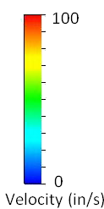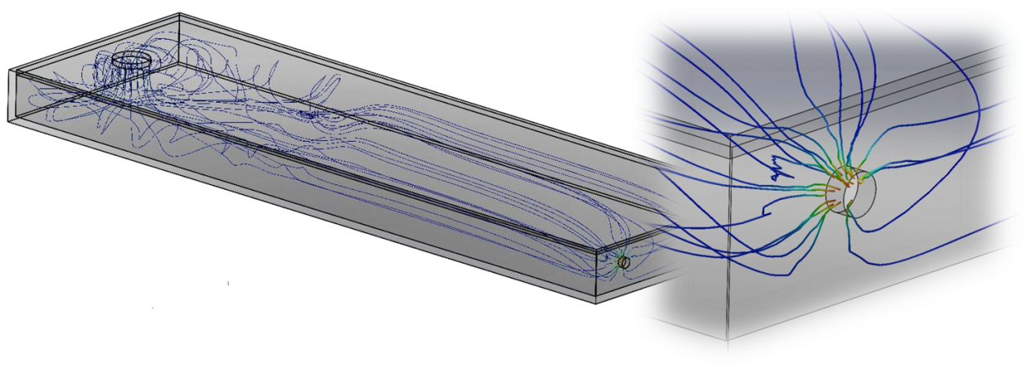In order to make sure the outflow valve would be low enough to reduce the amount of unusable storage but high enough to reduce any particulate resuspension that would occur, SolidWorks was used to perform a FloXpress Analysis of the tank. A simulation tank was created which assumed a water depth of 5 inches with the outflow valve 3 inches above the bottom of the tank. According to the simulation, the velocity of the water just before the outflow where the resuspension would be least desirable was 10 inches per second. This speed is not high enough to create the shear force that would resuspend any particles settled in the tank.

***Figure 5:*** *FloXpress simulation modeling the flow within a nearly empty storage tank*.

The tank itself is rectangular in shape and is constructed from the same HDPE that is used for the rest of the structure. The entire tank structure is 23 ½ inches tall, 72 inches wide, and 20 inches deep. The only entrance to the tank is through the downspout system that collects water from the roof panels. This prevents direct contamination of the water systems by the intentional introduction of potentially contaminated water. The tank will also be painted with UV-blocking paint to prevent sunlight from entering the tank.

The tank is located on the ground at the base of the structure, as it would be impractical to transfer the load of all of the stored water to the structure. It is supported by a base that holds the floor of the tank 5 ½ inches above the ground. In total, there are 8 inches of space between the ground and the bottom of the outflow, allowing room to collect water from the tank.

The storage tank also features an overflow pipe. This allows excess water to exit the tank, instead of backing up into the delivery system, which could result in damage to the system and contamination in the water. The overflow pipe curves to exclude sunlight and is screened to prevent mosquitos from entering the tank.

## Collection Design

Because the tank rests on the ground, there must be a system that can transport water from the catchment surface to the tank. The catchment surface consists of the roof of the structure and the top of the power cap. If the ground is level, the top of the tank is 50 inches below a collection point along the bottom edge of the catchment surface.

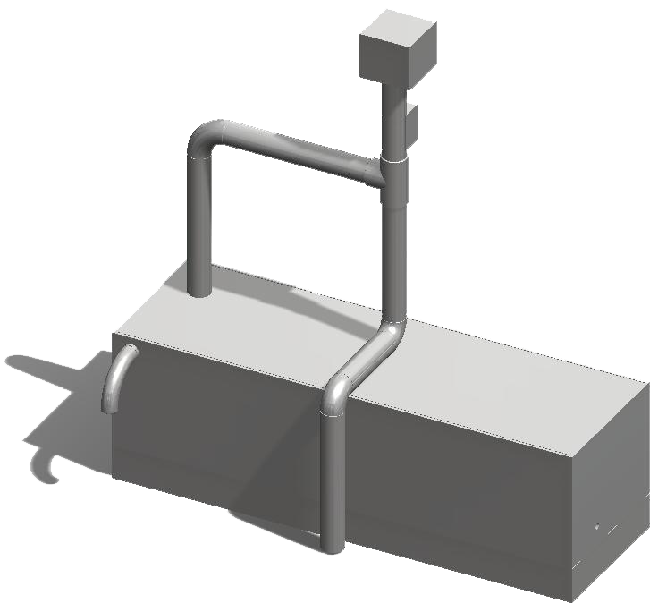To decrease cost and simplify production, the downspout system consists primarily of commercial polyvinyl chloride pipe. To exclude as much light as possible, the pipes will be painted with UV-blocking paint. The pipes will be 3 inch schedule 40 pipes, to maintain compatibility with the off-the-shelf diverter discussed below, while minimizing cost.

***Figure 6:*** *The downspout system transports collected rainwater from the roof panels into storage.*

## Cap - Assembly - Top ViewRoof Panels

The rainwater collection system collects rainwater from the external surfaces of the power cap and the roof panels. The total possible catchment area, counting only these surfaces, is about 145.7 square feet. The power cap includes downward-sloping gutters that run between the solar panels, allowing water to flow off of the solar panels and out from the center of the power cap’s surface onto the roof panels below.

***Figure 7:*** *Gutters between solar panel arrays funnel water onto the roof panels below.*

A simple gutter system was considered initially as a means of collecting water from the roof panels. This gutter would run around the perimeter of the structure, capturing water from all six roof panels. However, if this gutter were a separate piece, it would be too difficult for the residents to assemble without tools, especially because of the need to preserve the downward slope towards a common collection point. At the same time, incorporating such a gutter into the roof panels would introduce a number of failure points with the interfaces between the roof panels, and manufacturing tolerances would exacerbate this problem. This solution would also complicate assembly, which violates one of the primary requirements of the project.

The decision was made that funneling rainwater from all six roof panels to one common collection point is infeasible and incompatible with the design requirements. To simplify assembly for the inhabitants, it was determined that the water collection system would be incorporated directly onto the roof panels.

Two alternatives designs for the roof panels were developed. One design incorporated a concave roof panel that would redirect rainwater to a collection point at the bottom edge of the roof panel.

[IMAGE OF HEATHER’S ROOF PANEL]

[IMAGE OF HEATHER’S ROOF PANEL]

[IMAGE OF HEATHER’S ROOF PANEL]

[IMAGE OF HEATHER’S ROOF PANEL]

[IMAGE OF HEATHER’S ROOF PANEL]

[IMAGE OF HEATHER’S ROOF PANEL]

***Figure 8:***  *One roof panel design tested incorporated a contoured surface to direct rainwater to a collection point.*

The other was modeled after glides that are commonly used on roofs in Bermuda. These glides channel water to a collection point on the edge of the roof.

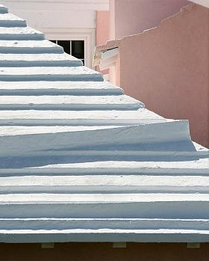

Three panels were constructed as 1:15.24 scale models: one curvature-based panel and two glides-based panels. These panels were tested with simulated rainfall. They were positioned at an angle of about 25 degrees, matching that found in the structure. Two tests were performed on each panel. A set amount of rainfall was simulated in each test, and the amount that could be collected from the panel was the measured dependent variable.

***Figure 9:***  *A glide designed to channel rainwater on a Bermuda rooftop.*

In the first test, water was sprayed at the panels. This test was designed primarily to yield qualitative data about water distributed across the entire panel. Unfortunately, experimental constraints made it impossible to properly control the height of the spray bottle above the panels. As a result, the quantitative data suggest that the contoured panel is more efficient than it actually is; the spray bottle had to be set lower for that test, resulting in less waste due to inaccurate spraying. However, the qualitative results of observation made it clear that the centered glide design was most efficient in channeling water to the collection point from all parts of the panel.

|  |  |  |  |  |  |
| --- | --- | --- | --- | --- | --- |
| Panel | Rise | Run | Number of Squirts | Amt. Sprayed | Amt. Collected |
| Contoured | 1.5 | 3.15 | 50 | 50 mL | 28 mL |
| Glides (middle) | 1.5 | 3.15 | 50 | 50 mL | 26 mL |
| Glides (off-center)  ***Table 3:***  *Data collected from the Spray Test for all three roof panel designs. See description in text regarding accuracy of measurements.* | 1.5 | 3.15 | 50 | 50 mL | 16 mL |

The second test was more focused on quantitative data. In this test, simulated rainfall was delivered to the panels in a concentrated grouping of streams. This test simulated continuous rainfall to ensure waste would not occur as a result of large volumes of water. In this test, the glides designs strongly outperformed the contoured design, resulting in the least waste. Also, the amount of water introduced to the panels in these tests is equivalent to 6 inches of rainfall in the 35 second time span, well beyond the normal range of rainfall. Real-world efficiency should be much better.

|  |  |  |  |  |  |  |
| --- | --- | --- | --- | --- | --- | --- |
| Panel | Rise | Run | Water in Cup | Time | Remaining in Cup | Collected |
| Contoured | 1.5 | 3.15 | 400 mL | 35 sec | 50 mL | 225 mL |
| Glides (middle) | 1.5 | 3.15 | 400 mL | 35 sec | 50 mL | 305 mL |
| Glides (off-center)  ***Table 4:***  *Data collected from the Simulated Rainfall Test for all three roof panel designs. See description in text regarding accuracy of measurements.* | 1.5 | 3.15 | 400 mL | 35 sec | 50 mL | 275 mL |

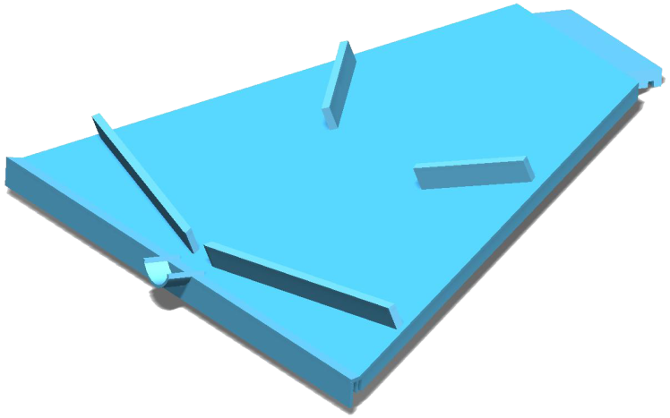Based on these test results, the glide design was determined to be the most efficient. Additionally, the glides design is easier and less expensive to implement than the contoured design, as it does not require complex and precise shaping of an entire roof panel. The design includes four glides on each roof panel. They stand out 3 inches orthogonally from the plane of the roof panel. Two glides on the upper half of the panel direct much of the water flowing from the power cap towards the center of the panel. Two longer glides along the lower side of the panel direct all rainwater towards the central collection point. Additionally, a 3.58 inch gutter extends directly out from the roof panel to help shape the stream of water as it enters the downspout system.

***Figure 10:*** *The final glide-based roof panel design, with a short gutter at the base.*

## Mesh Filters

An important goal in the design of a water catchment system is the exclusion of debris from water storage as well as from the downpipe. To that end, the system includes two meshes to filter inflow from the catchment surface. The design here is based on review of the literature on rainfall catchment systems.

The first mesh intercepts the water as it runs off of the roof panel and through the 3.58 inch roof gutter. This mesh is 5mm and sits at an angle of 60 degrees to the horizontal plane. It sits on a pvc housing through which incoming rainwater flows, and which is attached to the top of the downspout. Any debris larger than 5mm washed off of the roof panel with collected rainwater is caught by this mesh. Because of the incline, the water flowing through the mesh will wash the debris off of the mesh and away from the downspout system.

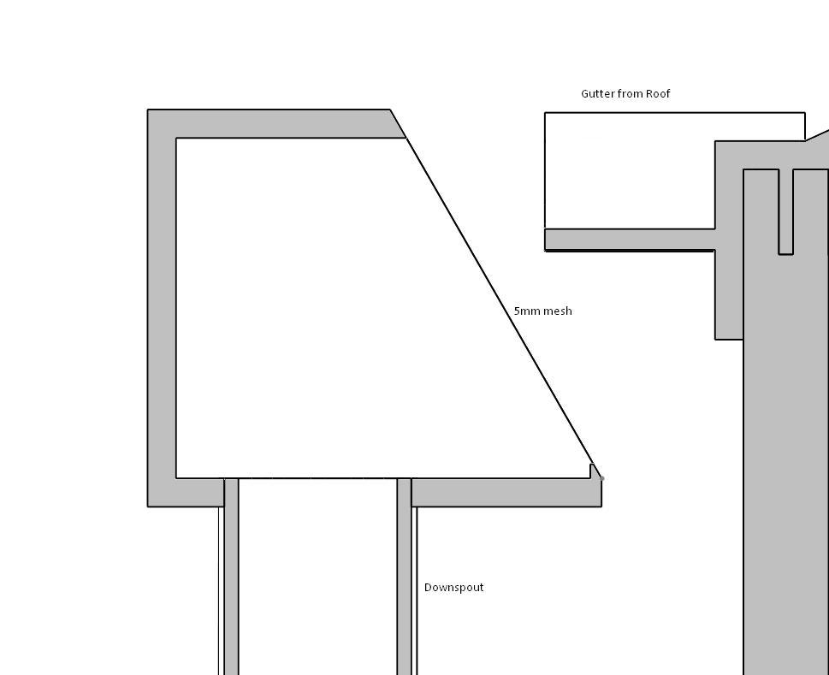

***Figure 11:***  *Rainwater running from the roof panel passes through a 5mm mesh before entering the downspout assembly.*

The second mesh is located within the downspout and begins less than 7 inches below the inflow to the downspout system. This mesh is 1mm and sits at the same angle as the 5mm mesh to allow it to be similarly self-cleaning. In order to allow caught debris to escape, a debris egress is cut out of the pipe. 180 degrees of the pipe is removed along the 5 2/3 inch height that the 1mm mesh spans. This opening is covered by a shield to preclude light from entering the system and promoting algae growth, as well as limiting access to the system by vermin.

The short gutter at the edge of the roof panel directs the stream of water towards the 5mm inflow mesh. However, inside the downspout, the flow of water is less controlled. To direct water away from the debris egress and towards the 1mm mesh, the design features an angled ledge obstructing the interior leading half of the pipe. This ledge prevents water from falling down the side of the debris egress, allowing it to pass through the 1mm mesh instead.

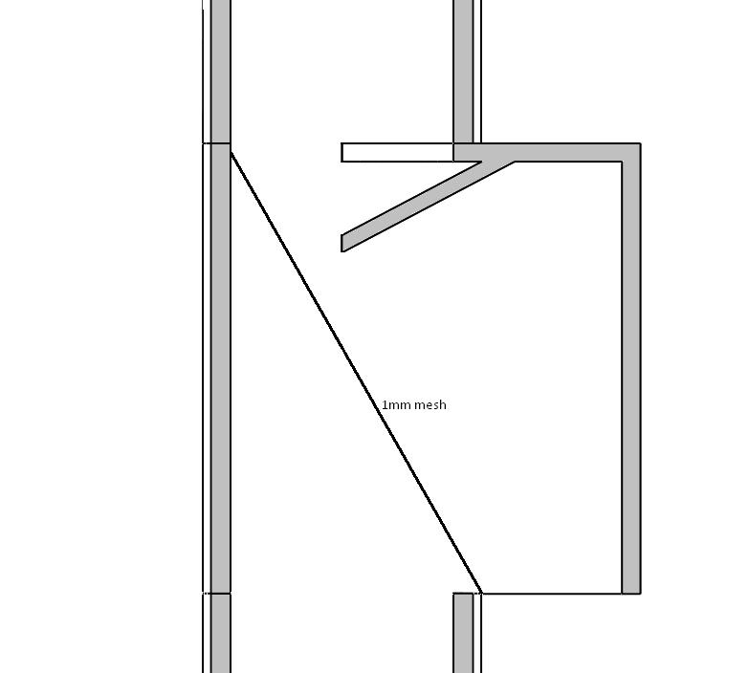

***Figure 12:***  *Within the downspout assembly, rainwater passes through a self-cleaning 1mm mesh, while small debris is washed from the mesh and exits the downspout.*

Because the meshes are self-cleaning, a clear path of egress for debris exists at the base of the mesh. As a result, flowing water may also be at risk for escape. Experimentation was performed to determine how fine a mesh could be used without losing water. Any mesh finer than 1mm resulted in significant water running along the top of the mesh and escaping capture. Meshes with openings 1mm or larger allowed all water to pass through when they were oriented properly. This result, coupled with the literature review, drove the design decision to include a 1mm mesh as the smallest debris filtration.

## First Flush Diverter

Rainwater is generally clean until it comes into contact with a dirty surface. The catchment surface itself is often the primary source of contamination. However, as rainwater runs over the catchment surface, the surface becomes cleaner. As a result, the early runoff of rainwater from the catchment surface is considerably less clean than subsequent runoff. If the initial runoff can be diverted from water storage, water quality can be significantly improved.

A first flush diverter is a device that does just this. Research has shown that first flush diverters in the field have been problematic. Many types that have been used are prone to failure. Many designs require human maintenance to empty the first flush receptacle. Some designs require the user to physically move the downspout to engage the diverter. These types of designs fail when users fail to use them correctly. In fact, users have been found to intentionally force them to fail, perhaps to collect more of the rainwater for consumption. At best, these failures simply sabotage the usefulness of the first flush diverter. At worst, they can render the system unable to collect water, or seriously compromise water quality.

A successful first flush diverter must require little maintenance and operate without human intervention. The requirements of the HOME dictate that there can be no formal training and little in the way of instructions. The design of the first flush diverter must then allow for intuitive operation and reduce the possibility for human error.

RainHarvest offers a commercially available first flush diverter that meets these requirements. A ball is suspended in the water as it collects in the diverter's reservoir. When the reservoir fills, the ball forms a seal with the seat at the top of the reservoir, allowing water subsequently collected to reach the storage tank. The water sequestered in the diverter is allowed to escape slowly through a small valve in the bottom of the reservoir. The reservoir is empty before that catchment surface is dirty again. All of these operations take place without any human activity.

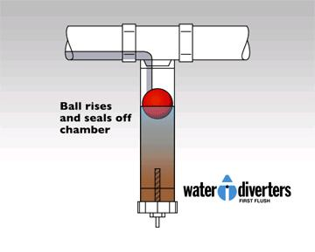

***Figure 13:***  *The ball suspended in the first flush diverter rises as the reservoir fills, and creates a seal when the correct amount of water has been diverted.*

Guidelines vary for the volume of water to be diverted, but they center around 1mm of rainfall. Assuming one hundred percent collection efficiency from one roof panel and that exactly one sixth of the power cap surface is usable for collection from one roof panel, the first 1mm of rainfall yields 0.596 gallons of water to be diverted. Because the diverter uses the same 3” schedule 40 polyvinyl chloride pipe as the downpipe assembly, approximately 19 inches of diverter reservoir are needed.

This design presents two primary concerns. One of these concerns is the eventual blockage of the exit valve, or blockage of the filter that screens larger particles from reaching the valve. Without the possibility for formal training or detailed instructions, the inhabitants cannot be expected to perform proper maintenance. However, the systems are expected to function for three to five years. This creates a concern that the valve will cease to function correctly after extended usage.

The diverter was tested for blockages in a laboratory setting, using a range of different valve sizes. The product includes 8 valves ranging from 0.25mm to 2mm. The 0.25mm, 0.5mm, 1mm, and 2mm valves were selected for testing. A dust preparation was composed primarily of sander dust. A mixture of 9g of dust preparation and 200mL of water was poured into the diverter with each test valve. The 0.25mm valve blocked completely. Each other valve showed reductions in exit flow rate, with the 0.5mm valve slowing to a drip.

The second concern is that the flow rate out of the valve will represent a significant loss in water collected. The flow rate of water out of each valve was calculated using 19 inches of water pressure.

***Table 5:***  *Calculated flow rates from the slow-drip egress valve from the first flush diverter reservoir. A constant water depth of 19 inches is assumed.*

|  |  |  |  |  |  |  |  |  |
| --- | --- | --- | --- | --- | --- | --- | --- | --- |
| Valve Size (mm) | 0.25 | 0.5 | 0.75 | 1 | 1.25 | 1.5 | 1.75 | 2 |
| Flow Rate (gal/min) | 0.00239 | 0.00958 | 0.0215 | 0.0383 | 0.0599 | 0.0862 | 0.117 | 0.153 |

Rainfall of 0.1 in/hr, which is the approximate boundary between light rainfall and moderate rainfall, yields 0.0252 gal/min potential collected water. The 0.75mm valve would result in a loss of 85 percent of rainwater in these conditions, even under 100 percent collection efficiency. If the rate of rainfall increases to 0.3 in/hr, which represents the boundary between moderate and heavy rain, rainfall collected increases to 0.0757 gal/min if collection efficiency is 100 percent. This still results in loss of 28 percent of rainwater. The fact that 0.596 gallons of water are already lost to the diverter reservoir compounds these difficulties.

In light of these calculations, the smallest valve possible must be recommended for use in the HOME. The 0.5mm valve loses less than half the water that the 0.75mm valve loses, and can collect an appreciable amount of water in light rain if the storm persists long enough to fill the diverter reservoir. The 0.25mm valve loses less than a quarter what the 0.5mm valve loses, making it vastly superior for water collection, but the results from the blockage experiments make it difficult to recommend the 0.25mm valve.

## Design By Region

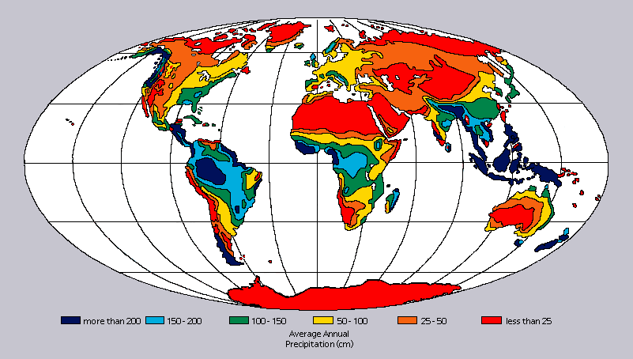The HOME is intended for use wherever internally displaced persons need a better solution for housing. Because rainfall patterns vary greatly between different regions of the world, the rainwater collection system must be adaptable.

***Figure 14:***  *Average annual precipitation varies immensely around the globe. The water system must be designed to function in a wide range of climates.*

The degree to which the HOME can provide the primary source of water for a family depends on the rainfall patterns of the site. Ultimately, the system is designed to be a supplemental source of water. It provides a relatively small reserve of water that can be invaluable in times of increased need and when other sources of clean water are delayed or otherwise unavailable. Because the tank can provide water storage for only ten to twenty days for four inhabitants, one tank will never store enough water to last through the extensive dry season that many regions experience.

A critical decision comes with the selection of valve size for the first flush diverter. The size of the valve dramatically affects how much water is lost during a rainstorm. In areas with less rain, and in particular with lighter rain, the volume of water lost through the valve is substantial, and a smaller valve is more desirable. However, in areas with infrequent rain, and where a layer of sediment can accumulate on the roof panels, blockage of the valve may be more of a danger. A larger valve may mitigate the risks of blockage. Unfortunately, these two considerations often coincide and conflict, making the selection of valve size especially critical.

The diversion volume is based on 1mm of rainwater diversion. Many factors, including the distribution of rainfall and presence of windborne particles, influence the desired amount of water to be excluded from storage. A region with rainfall that is frequent year-round may require less diversion, as there is less opportunity for the catchment surface to become contaminated between rainstorms. If potentially contaminated particles frequently blow onto the catchment surfaces, more diversion may be desirable.

Dry climates in particular present the most obstacles to an effective rainwater system design. The optimal solution for these areas may be to use multiple storage tanks and collection systems. Because the design is modular, up to five systems may be attached to the HOME. This allows five times the collection and five times the storage that one tank offers. 400 gallons of storage could allow a family to survive the dry season if they can save up enough water during the rainy season and ration effectively throughout the dry season. Of course, this configuration will cost somewhat more and require five water systems to be shipped and installed for each HOME.

Finally, it is important to realize that the requirement for no training does not preclude the inhabitants from exercising common sense. Inhabitants will realize that the water systems are collecting water from the roof panels. They certainly will want their water to be clean. The structure is designed to allow access to the roof, and it is quite possible that inhabitants will attempt to keep the roof panels clean. To some degree, this may mitigate the risk of blockages in the first flush diverter even in areas with high levels of sediment deposits.

## Remaining Design Questions

A number of questions remain regarding the water systems. First, a number of potential improvements might be made. First, in order to account for ground shifting or structural irregularities, it might be beneficial to allow the height of the downspout to be adjustable. Second, a custom reservoir might be built for the first flush diverter that would have a larger diameter. This would reduce the water pressure, allowing water to exit the reservoir more slowly, and increasing water collection efficiency. These improvements would certainly increase manufacturing costs and might introduce greater possibility of failure, but they could offer tangible improvements to the HOME.

A third improvement might lie in the introduction of an additional filtration mechanism, such as an activated carbon filter, at the outflow of the tank. Water quality improvements yielded at this stage would mostly be cosmetic, but it would also add some redundancy to the filtration system, which can be important when human safety is at stake. This would certainly be more costly, and would require testing to determine how well such a filter could stand up over three to five years.

This design largely ignores the specifics of manufacture, and the entire system needs to be prepared for production. However, some aspects of the water system need particular attention in this regard. The 5mm and 1mm meshes need to be attached to their housings in some way, and this method of attachment is not designed. The faucet on the outflow of the storage tank also needs to be designed for manufacture. Additionally, the custom fabrication of the storage tank may not prove to be cost-effective, and commercial, off-the-shelf options should be explored.

Extensive long-term and full-scale testing must be performed before the HOME is shipped to be used by human beings, and the water system is no exception. In addition to testing ordinary use, many specific tests must be performed. These include algae-growth studies, particularly in the areas near the self-cleaning meshes that might be vulnerable to algae growth. The first flush diverter must be tested for long-term clogging. The power cap should also be tested to verify that the gutters between solar panels are not prone to debris blockages. The storage tank must also be tested for structural integrity under both water pressure and live human loads over the long term.

### Power and Electrical Systems

Power generation and use are among the most important requirements of the HOME. Sustainable power generation is a major factor in differentiating this structure from traditional transitional housing. The first step in designing the power system was to determine the load demands through power usage. Since the HOME cannot have windows, the only sources of natural light are the small holes for ventilation within the wall panels, or door panel if the door is left open. To compensate for this lack of natural light, occupants will need a source of lighting for approximately ten to twelve hours each day. Due to the hexagonal shape of the structure, it was determined that six lights, one corresponding to each wall panel, would be added to the interior of the power cap. Recessed lighting was selected for its simple integration into the cap design. Lights will be installed during manufacturing to minimize occupant setup. Light-emitting diode (LED) bulbs were chosen due to their extremely low wattage and long life-span, in comparison to traditional incandescent bulbs. This should minimize, if not eliminate, the need for occupants to change light bulbs. Use of six bulbs, each five Watts, for twelve hours a day creates a daily electrical load demand of three hundred sixty Watt-hours for lighting.

Lighting controls such as dimmers or the setting of three lights on one switch and three on another switch were also discussed. It was quickly determined that both of these options would complicate the circuitry design and add failure modes. As an alternative, caps or covers will be provided to offer more lighting options.

The initial design incorporates an outlet so that the occupants can charge laptops, cell phones, or other electronic devices. The preliminary location of this outlet is within the collar of the power cap, but is also being considered in the door panel. It has been assumed that the outlet will be used at one hundred Watts for five hours a day, for a total of five hundred Watt-hours per day.

The combined load of lighting and the outlet is eight hundred sixty Watt-hours each day. The original power source considered, as stated in the requirements provided by the client, was solar power. Due to the less-than-reliable nature of solar power, it was determined early on that the final design should be able to provide more than one day of power. A timeframe of three days was chosen, such that rain or cloudy days would not leave occupants without power. This prompted the working power goal of 2.6 kilowatt hours of storage.

# Options for Power Generation

With the electrical load demands calculated, a source or multiple sources of power were needed to meet these needs. A list of possible sustainable energy sources was created and quickly evaluated. The four major energy options considered were wind, solar, fuel cell, and human energies.

## Wind

The initial design provided by the client incorporated a wind turbine. Wind power accounts well for human factors in some ways, in that it is clean and requires minimal effort from the occupants during normal functioning. Additionally, wind meets the renewability requirement for power.

However, wind power has a number of substantial drawbacks. An initial concern was the complexity of a wind turbine, as comprehensive wind studies would be necessary for the turbine to be efficient. Typical wind studies take one to two months, a timeframe that disaster victims do not have. In addition, these studies require tools and background knowledge which would not be available to the displaced persons. Most significantly, the scale required of the wind turbine proved to be completely impractical; when calculations were completed, it was determined that the height of the turbine would need to be six hundred and eighty seven feet in order to provide the power generation needed just to power the lights. These calculations were completed using average wind speeds for Bristol, Rhode Island and assuming very low levels of obstruction, such as buildings, trees, or even bushes. These would be the most optimal conditions, and so the scale of a wind turbine required in most areas of the world would be much larger than nine hundred feet in height. Attaching it to the structure would have tremendous structural ramifications. A twelve foot diameter structure with little connection to the ground could not possibly support a six to nine hundred foot structure. The complexity of the wind turbine also drives a large monetary cost. Finally, maintenance and potential failures could pose significant problems for the occupants, which impacts negatively on human factors. These considerations quickly ruled out wind power as a viable source for our needs.

## Fuel Cell

Another means of power production considered was the use of fuel cells. The fuel cell is by far the most efficient means of power generation considered for this project, and fuel cells are fairly compact. Also, the only byproduct produced by the use of fuel cells is water. This water might in fact be useful to the occupants.

However, the use of fuel cells poses a major concern. The fuel source used in a fuel cell is hydrogen. The safety of the occupants is a primary concern, and maintaining standing reserves of hydrogen poses a fire danger. Additionally, the logistics of providing a continual supply of fuel would increase overhead dramatically.

## Solar

Solar power was written into the requirements by the client, as a primary means of power generation. Like wind, solar power accounts for human factors and renewability. Solar power is extremely simple for the occupants, who need only keep the panels clear of debris if they want to maintain high efficiency. The geographical target areas for our product generally provide consistent sunlight. Solar power is generally reliable, fairly compact, and reasonably low-weight.

The main drawbacks of solar power are fragility and efficiency. Fragility can be mitigated by the use of polycrystalline or amorphic panels, which are much more durable than monocrystalline. The lower efficiency of solar panels manifests in a higher manufacturing cost, owing to the surface area required to produce enough power.

## Human

The final power requirement requested by the mentor was some form of human power. This would provide occupants with a means of creating their own energy, and have better control of their available power use. Human power is very low-cost in terms of manufacturing, and is extremely compact, low-weight, and reliable. It also offers the additional advantage that the users can produce the amount of energy that they need. For example, while the design requirements assume charging a laptop computer or cell phone for three hours each day, if the users don’t need this they can simply spend less time cranking.

Drawbacks for human power include the human factors requirement. It is less than desirable to require occupants to crank for their own electricity, especially when most are women and children, and many more might be injured or handicapped. Under these conditions, the efficiency of human power might also be less than reliable. These drawbacks can be mitigated by incorporating multiple power systems, such that the human power system can be used as supplementary if it is a hardship on the occupants.

After reviewing and discussing these four power alternatives, it was decided that wind turbines and fuel cells were not practical for HOME powering purposes. With the conclusion that solar and human powers were the most viable sources, it was time to move on to determine what percentage each source would provide as well as how to integrate them into the structure.

# Calculations and Analysis

With power generation options narrowed to two sources, research, calculations, and analyzation began.

## Solar

Solar energy is typically harnessed and converted to electricity in one of two methods. On a large scale, it can be completed in concentrating solar power plants, which use heat from many solar thermal collectors to heat a fluid and produce steam. The steam is then used to turn and power a generator. This method requires a vast area and in the United States is only used successfully in the Southwest, with nine plants in California, one in Arizona, and one in Nevada. For HOME purposes, a concentrating solar power plant is impractical.

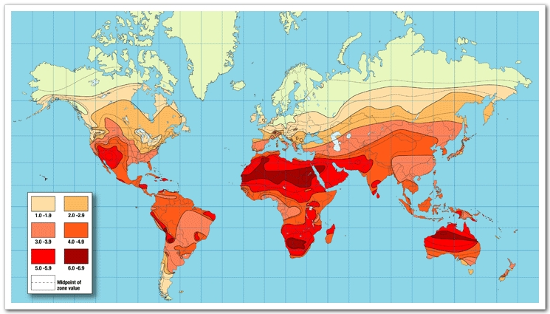The more common and household process of converting solar energy into electricity is through photovoltaic (PV) devices, or solar cells. Solar cells convert sunlight directly to electricity and are grouped into panels and arrays of panels. These panels are most often viewed on the roofs of houses and buildings. The size of panels and arrays is driven by the efficiency of the individual panels, power of sunlight at the location, as well as power needs. The power of sunlight in a region is calculated through a constant called insolation.

***Figure 15:*** *World map of insolation coefficient values. Note that the key indicates darker colors as higher coefficients and that the target areas for HOME use also have the darkest areas.*

Insolation values for the same countries studied for average rainfall data can be viewed in the table below.

Country Insolation Data

|  |  |
| --- | --- |
| **Indonesia** | 4.0 - 4.9 |
| **Haiti** | 5.0 – 5.9 |
| **Egypt** | 5.0 – 6.9 |
| **Kenya** | 4.0 – 4.9 |
| **South Africa** | 5.0 – 6.9 |
| **Thailand** | 4.0 – 4.9 |
| **Brazil**  ***Table 6:*** *Insolation coefficient values for seven studied countries.* | 3.0 – 4.9 |

Insolation varies from 0 to 6.9; the high values viewed in the chart above show solar power to be an extremely viable power source in most regions that the HOME is projected to be used.

The three major types of photovoltaic cells are polycrystalline, monocrystalline and amorphic. Each type of cell has different characteristics and efficiency ratings. Monocrystalline has the highest efficiency, at about 16% but is the most fragile. Polycrystalline is less efficient, with an average of 14%, but is less fragile. The most durable and flexible of the cells is amorphic, but it is by far the least efficient, with an average of 6% efficiency. Following the use of a Kepner Tragoe Analysis Trade-Off Study, it was decided that polycrystalline panels would be used. Polycrystalline panels were selected for the design, as they provide a good balance of adequate durability and efficiency near that of monocrystalline.

Extensive research into innovative and lightweight solar arrays was completed. Some options considered were solar shingles, tracking panels, and small panels mimicking the leaves of an ivy plant. Tracking panels are programmed to change position as the sun’s position changes throughout the day. They are a great asset in capturing the maximum amount of the sun’s rays. Unfortunately, these panels would require a sun study, similar to the wind study needed for a wind turbine. They also add moving parts and a level of complexity to the power cap which may compromise the structure. These aspects removed tracking panels from selection. Ivy-mimicking panels also require basic knowledge of how solar panels work as well as setup. If the “leaves” are not turned properly, no light will be collected and the system will be rendered useless. This system is also designed for a much smaller scale than what would meet the power needs of the HOME, and has been ruled as no more than an interesting concept. Roof shingles containing photovoltaic cells were the innovative option most closely fitting the power requirements. Shingles are installed and wired during the manufacturing process, which means it is unnecessary for users to complete any wiring. With further research, several manufacturers, such as Owens-Corning and DOW Chemical, were found to be advertising such solar shingles. Unfortunately, neither company will be producing the shingles for several months and have not published specifications or cost data for their products. Without this information, there is no possibility of sizing a solar shingle system and after further consideration, it was determined that shingles would be too fragile and brittle to rely on during shipment and setup. A solid surface is considerably more desirable.

Following the research and discounting of innovative photovoltaic arrays, the team decided to focus on more traditional solar panels. A number of polycrystalline solar panels were researched and compared based on power output, efficiency, size, weight, durability, and cost. Some panels were ruled out immediately, and the remaining were used to find an assumed average expected output value for the remainder of our calculations.

|  |  |
| --- | --- |
| Power Output (after efficiency is accounted for) | 30 Watts |
| Surface Area | 424.44 in2 |
| Thickness | 0.5 – 1 in |
| Weight | 7.71 lb |
| Optimum Angle (from horizontal) | 25˚ |
| Cost  ***Table 7:*** *Assumed values for panel characteristics. Taken from an average of researched panels and used for all following solar panel calculations.* | $180 |

These numbers were used to create a variety of scenarios, based on the amount of power expected from the solar panels. The results of this trade-off study are as follows:

|  |  |  |  |  |  |  |  |  |  |  |
| --- | --- | --- | --- | --- | --- | --- | --- | --- | --- | --- |
|  | | |  | | |  | | |  |  |
| Load Demand | **0** | | **Wh** |  | |  |  | Load Demand | | | **325** | **Wh** |  |  |
|  | | | | | | |  |  | | | | | | |
| Panel Capacity | 30 | | W/Panel | | |  |  | Panel Capacity | | | 30 | W/Panel | |  |
| Sun Time | 5 | | Hr/Day | | |  |  | Sun Time | | | 5 | Hr/Day | |  |
| Area of Panel | 424.44 | | sq. in. | | |  |  | Area of Panel | | | 424.44 | sq. in. | |  |
| Cost/Panel | 180 | |  |  | |  |  | Cost/Panel | | | 180 |  |  |  |
| # panels needed | **0** | |  |  | |  |  | # panels needed | | | **2.17** |  |  |  |
| Area of Cap | 0 | | in sq. |  | |  |  | Area of Cap | | | 919.62 | in sq. |  |  |
| Radius of Hexagon | 0 | | in or | 0 | | feet |  | Radius of Hexagon | | | 18.81 | in or | 1.57 | feet |
| Cost | **$0** | |  |  | |  |  | Cost | | | **$390** |  |  |  |
|  |  | |  |  | |  |  |  | | |  |  |  |  |
| Load Demand | **650** | | Wh |  | |  |  | Load Demand | | | **975** | Wh |  |  |
|  | | | | | | |  |  | | | | | | |
| Panel Capacity | 30 | | W/Panel | | |  |  | Panel Capacity | | | 30 | W/Panel | |  |
| Sun Time | 5 | | Hr/Day | | |  |  | Sun Time | | | 5 | Hr/Day | |  |
| Area of Panel | 424.44 | | sq. in. | | |  |  | Area of Panel | | | 424.44 | sq. in. | |  |
| Cost/Panel | 180 | |  |  | |  |  | Cost/Panel | | | 180 |  |  |  |
| # panels needed | **4.33** | |  |  | |  |  | # panels needed | | | **6.50** |  |  |  |
| Area of Cap | 1839.24 | | in sq. |  | |  |  | Area of Cap | | | 2758.86 | in sq. |  |  |
| Radius of Hexagon | 26.61 | | in or | 2.22 | | feet |  | Radius of Hexagon | | | 32.59 | in or | 2.72 | feet |
| Cost | **$780** | |  |  | |  |  | Cost | | | **$1,170** |  |  |  |
|  |  | |  |  | |  |  |  | | |  |  |  |  |
| Load Demand | **1300** | | Wh | | | |  | Load Demand | | | **1525** | Wh | | |
|  | | | | | | |  |  | | | | | | |
| Panel Capacity | 30 | | W/Panel | | | |  | Panel Capacity | | | 30 | W/Panel | | |
| Sun Time | 5 | | Hr/Day | | | |  | Sun Time | | | 5 | Hr/Day | | |
| Area of Panel | 424.44 | | sq. in. | | | |  | Area of Panel | | | 424.44 | sq. in. | | |
| Cost/Panel | 180 | |  | | | |  | Cost/Panel | | | 180 |  | | |
| # panels needed | **8.67** | |  |  | |  |  | # panels needed | | | **10.17** |  |  |  |
| Area of Cap | 3678.48 | | in sq. | | | |  | Area of Cap | | | 4315.14 | in sq. | | |
| Radius of Hexagon | 37.63 | | in or | 3.14 | | feet |  | Radius of Hexagon | | | 40.75 | in or | 3.40 | feet |
| Cost | **$1,560** | |  |  | |  |  | Cost | | | **$1,830** |  |  |  |
|  |  | |  |  | |  |  |  | | |  |  |  |  |
| Load Demand | **1950** | | Wh | | | |  | Load Demand | | | **2275** | Wh | | |
|  | | | | | | |  |  | | | | | | |
| Panel Capacity | 30 | | W/Panel | | | |  | Panel Capacity | | | 30 | W/Panel | | |
| Sun Time | 5 | | Hr/Day | | | |  | Sun Time | | | 5 | Hr/Day | | |
| Area of Panel | 424.44 | | sq. in. | | | |  | Area of Panel | | | 424.44 | sq. in. | | |
| Cost/Panel | 180 | |  | | | |  | Cost/Panel | | | 180 |  | | |
| # panels needed | **13.00** | |  |  | |  |  | # panels needed | | | **15.17** |  |  |  |
| Area of Cap | 5517.72 | | in sq. | | | |  | Area of Cap | | | 6437.34 | in sq. | | |
| Radius of Hexagon | 46.08 | | in or | 3.84 | | feet |  | Radius of Hexagon | | | 49.78 | in or | 4.15 | feet |
| Cost | **$2,340** | |  |  | |  |  | Cost | | | **$2,730** |  |  |  |
|  |  | |  |  | |  |  |  | | |  |  |  |  |
| Load Demand | **2600** | | Wh | | | |  |  | | |  |  |  |  |
|  | | | | | | |  |  | | |  |  |  |  |
| Panel Capacity | 30 | | W/Panel | | | |  |  | | |  |  |  |  |
| Sun Time | 5 | | Hr/Day | | | |  |  | | |  |  |  |  |
| Area of Panel | 424.44 | | sq. in. | | | |  |  | | |  |  |  |  |
| Cost/Panel | 180 | |  | | | |  |  | | |  |  |  |  |
| # panels needed | **17.33** | |  |  | |  |  |  | | |  |  |  |  |
| Area of Cap | 7356.96 | | in sq. | | | |  |  | | |  |  |  |  |
| Radius of Hexagon | 53.21 | | in or | 4.43 | | feet |  |  | | |  |  |  |  |
| Cost  ***Table 8:*** *Series of calculations of different solar panel outputs, through the use of Excel™. The expected output (load demand) cell was changed in each scenario to create a series of panel sizes and costs.* | **$3,120** | |  |  | |  |  |  | | |  |  |  |  |

As can be seen from these tables, relying solely on solar energy to fill the 2.6 kilowatt hour load demand would result in an almost four and a half foot radius hexagon for the cap and would cost $3,120. This is nearly three times the allocated cost for the entire power system, and therefore violates the power system requirements. The power source cannot come from solar energy alone.

## Human

The implementation of the human power design is accomplished most simply by the use of a hand crank. Still under consideration is the use of a simple leg powered crank, as the human body can produce much more power by the use of the legs. Using a leg crank does present a tradeoff, as the simplicity of design would suffer. The inclusion a leg powered mechanism would require a seat for the occupant as well as adjustable pedals.

The use of human power also introduces complications in the wiring. Originally all of the wiring was to be located in the power cap to eliminate electrical interfaces between structural panels. However, for ease of access for the occupants, the crank would need to be easily accessible. Children will need to be able to help with power production, and for that to be possible, the crank will need to be low enough for them to reach. Therefore it must go on the one unique wall panel which also contains the door.

With the completion of research concerning the rates of power generation available through a hand crank, a study similar to that of the solar energy was done to find how much power could be created, depending on the rate and length of cranking.

|  |  |  |  |  |  |  |
| --- | --- | --- | --- | --- | --- | --- |
| Load Demand | **0** | **Wh** |  | Load Demand | **1350** | **Wh** |
|  |  |  |  |  |  |  |
| Rate for Adult | 150 | W/hr |  | Rate for Adult | 150 | W/hr |
| Rate for Child | 75 | W/hr |  | Rate for Child | 75 | W/hr |
| Hours Adult | **0** | hours/day |  | Hours Adult | **2** | hours/day |
| Hours Child | **0** | hours/day |  | Hours Child | **2** | hours/day |
| Power Generated | 0 | Wh/d |  | Power Generated | 450 | Wh/d |
|  |  |  |  |  |  |  |
| Load Demand | **1800** | **Wh** |  | Load Demand | **2250** | **Wh** |
|  |  |  |  |  |  |  |
| Rate for Adult | 150 | W/hr |  | Rate for Adult | 150 | W/hr |
| Rate for Child | 75 | W/hr |  | Rate for Child | 75 | W/hr |
| Hours Adult | **3** | hours/day |  | Hours Adult | **4** | hours/day |
| Hours Child | **2** | hours/day |  | Hours Child | **2** | hours/day |
| Power Generated | 600 | Wh/d |  | Power Generated | 750 | Wh/d |
|  |  |  |  |  |  |  |
| Load Demand | **2475** | **Wh** |  | Load Demand | **3375** | **Wh** |
|  |  |  |  |  |  |  |
| Rate for Adult | 150 | W/hr |  | Rate for Adult | 150 | W/hr |
| Rate for Child | 75 | W/hr |  | Rate for Child | 75 | W/hr |
| Hours Adult | **4** | hours/day |  | Hours Adult | **5** | hours/day |
| Hours Child | **3** | hours/day |  | Hours Child | **5** | hours/day |
| Power Generated | 825 | Wh/d |  | Power Generated | 1125 | Wh/d |

As was the issue with relying exclusively on solar power, using solely human power in the HOME is ineffective as it would require occupants to crank for over seven hours a day to provide the desired 2.6 kilowatts. The power system will require a combination of the two sources of energy.

***Table 9:*** *Series of human power calculations, based on rate of and hours spent cranking, through the use of Excel™. In each case, the hours by adult and hours by a child were changed to find the power outputs of each situation.*

## Hand Crank Testing

An experiment was developed to account for the human factors like ease of use and human power capacities. A human powered crank was purchased though WindStream Power and minor changes were made to ensure a stable working platform. We then connected two millimeters, one to measure voltage and the other current. The crank was then arranged in four different positions and multiple trials were conducted to ensure accurate results. The positions included cranking with one hand, two hands, seated directly over the crank and seated at a forty five degree angle. Each participant partook in a timed trial which both voltage and current were recorded simultaneously. Results were recorded in five second time intervals and power output was calculated, as seen in figure below.

Under these conditions, the occupants will need to crank for 40 minutes to charge a laptop for just over an hour. The drawbacks can be mitigated by incorporating multiple power systems, such that the human power system can be used as supplementary if it is a hardship on the occupants.

|  |  |  |  |  |  |  |  |
| --- | --- | --- | --- | --- | --- | --- | --- |
| **Participant 1** | Foot A | | Foot B | | Hand A | | Hand B |
|  | 1 - Minute | 2 - Minute | 1 - Minute | 2 - Minute | 1 - Minute | 2 - Minute | 1 - Minute |
| **Max Power** |  | 1.703 |  | 0 |  | 3.309 | 1.470 |
| **Avg Power** | 1.157 | 1.126 |  | 0 | 1.258 | 1.147 | 1.104 |
| **Total Power** | 15.0755 | 28.144 |  | 0 | 16.083 | 28.675 | 14.348 |
|  |  |  |  |  |  |  |  |
| **Participant 2** | Foot A | | Foot B | | Hand A | | Hand B |
|  | 1 - Minute | 2 - Minute | 1 - Minute | 2 - Minute | 1 - Minute | 2 - Minute | 1 - Minute |
| **Max Power** |  | 0.960 |  | 0 | 0.250 | 1.156 | 1.937 |
| **Avg Power** | 0.606 | 0.675 |  | 0 | 0.559 | 0.637 | 1.244 |
| **Total Power** | 7.848 | 16.868 |  | 0 | 7.287 | 15.929 | 16.174 |
|  |  |  |  |  |  |  |  |
| **Participant 3** | Foot A | | Foot B | | Hand A | | Hand B |
|  | 1 - Minute | 2 - Minute | 1 - Minute | 2 - Minute | 1 - Minute | 2 - Minute | 1 - Minute |
| **Max Power** |  | 2.203 |  |  |  | 1.507 | 1.780 |
| **Avg Power** | 1.158 | 1.233 | 1.595 | 3.774 | 1.048 | 1.052 | 1.198 |
| **Total Power** | 14.408 | 30.836 | 20.191 | 43.037 | 13.567 | 26.291 | 15.568 |
|  |  |  |  |  |  |  |  |
| **Participant 4** | Foot A | | Foot B | | Hand A | | Hand B |
|  | 1 - Minute | 2 - Minute | 1 - Minute | 2 - Minute | 1 - Minute | 2 - Minute | 1 - Minute |
| **Max Power** |  | 2.190 |  |  |  | 1.966 | 2.568 |
| **Avg Power** | 1.431 | 1.617 | 1.962 | 1.891 | 0.814 | 0.876 | 1.754 |
| **Total Power** | 18.508 | 40.423 | 25.303 | 47.285 | 10.641 | 21.902 | 22.803 |

***Table 10:*** *Human power test results, based on recorded voltage and current. In each case the crank was placed in a different position and power output was calculated.*

***Figure 16 :*** *Graphical representation of the human power test results broken up by crank position. Each individual color represents a different participant’s trial.*

## Remaining Design Questions

After testing and determining the most power output would be generated in a seated position directly over the crank the next step is incorporating a seat for the occupants. Since the crank will be integrated into the base of the column design the seat will be need to be located on the column and somehow adjustable to allow use for all occupants. There are also still questions concerning the integration of the crank mechanism. Since all of the electrical components will be enclosed in the column it makes the most sense to place the crank at the base to offer the most support from unwanted vibrations. However, the actual interface and electrical connections have yet to be developed.

# Power Storage

A great deal of research was needed on different types of batteries, from shallow and deep cycle to traction. Traction batteries are used in most electric vehicles and should be fully discharged and recharged daily. Unfortunately, to use these batteries, it would have to be assumed that occupants would know to regularly discharge and recharge the batteries, and that they would actually do so. Assumptions on user knowledge and use cannot be made. The next researched battery was shallow cycle, which cannot tolerate the deep charge which is necessary in collecting solar power. Deep cycle batteries are the best option because they tolerate repeated discharging up to 80% and have a long lifespan. Deep charge batteries are produced in two different types: lead acid, which are similar to typical batteries that are readily available, and gel. Both of these battery types are low maintenance. The gel battery can be placed in any position and has no risk for spilling which is a positive consideration for health and safety risks, both to inhabitants and the environment.

The initial requirement for storage was set for three days’ worth of power needs, accounting for lighting and outlet usage. This is where the 2.6 kilowatt-hour load demand resulted from. When calculating the number, cost, and weight of batteries needed to store this load, it was found that this storage goal could not be attained. The weight of most batteries surpassed the allowed weight of the entire panel it would be contained in. Also, the cost of this number of batteries was similar to that of powering the entire project with solar paneling, well out of the budget. The 2.6 kWh needed to be lessened, and a discussion with the faculty mentor, Dr. Linda Riley, led to the reduction from three days of power storage to one day. Further research also showed that the assumption used to calculate power needed to charge a cell phone or laptop had been grossly overestimated, and so the final storage goal was reduced from 2.6 kilowatt-hours to 200 Watt-hours.

## Remaining Design Questions

The main concept of the HOME project is simplicity, whether in assembly or in use; this model was kept in mind when considering the location of the batteries and electrical components necessary. The initial thought was to keep all of the power components confined in the power cap; this would ensure that the wiring was tucked away and delivered fully functional. Another consideration and concern was the weight and structural attributes of the power cap. Each panel can weigh no more than sixty to seventy pounds so that occupants can easily assemble the structure; this limitation makes it virtually impossible to confine all of the electrical components in the power cap. Once the water storage was moved out of the column and to the exterior tank, it was determined that the electrical components will be placed on the inside of the column. This will result in decreased wiring, simplicity during manufacturing, and a smaller column size. The final components selected for the electrical system include, solar panels, a human power generator, recessed lighting (six units), a voltage regulator, battery, inverter and light switch.

While the team was able to select specific models for the human power generator, solar panels, and lighting it proved difficult to do so for the battery, voltage regulator, and inverter. Instead, the requirements for each were determined, and a list of suggestions was created. It was determined that a 12-Volt, deep charge battery which is rated for solar power collection will work best, and that this will be the largest of the components to be placed in the column. The average battery will fit in a Schedule 80 pvc pipe of eight inch diameter. The voltage regulator should be selected on the basis of the battery’s specifications, as should the inverter. The team also suggests that the selected inverter include the outlet, as to simplify wiring.

# Power Cap Design

The design of the actual power cap which will house the solar paneling, lighting, and most wiring began through sketching long before research began. It was quickly decided that the cap would be hexagonal in shape, to match the hexagonal main structure designed by the University of Rhode Island team. A collar would be placed on the underside of the cap to form a secure connection to the column. Initial dimensions state that the collar should be one inch thick and extend six inches into the interior of the column and should extend three feet at five inches thick on the outside of the column. These numbers will be adjusted based on initial structural analysis.

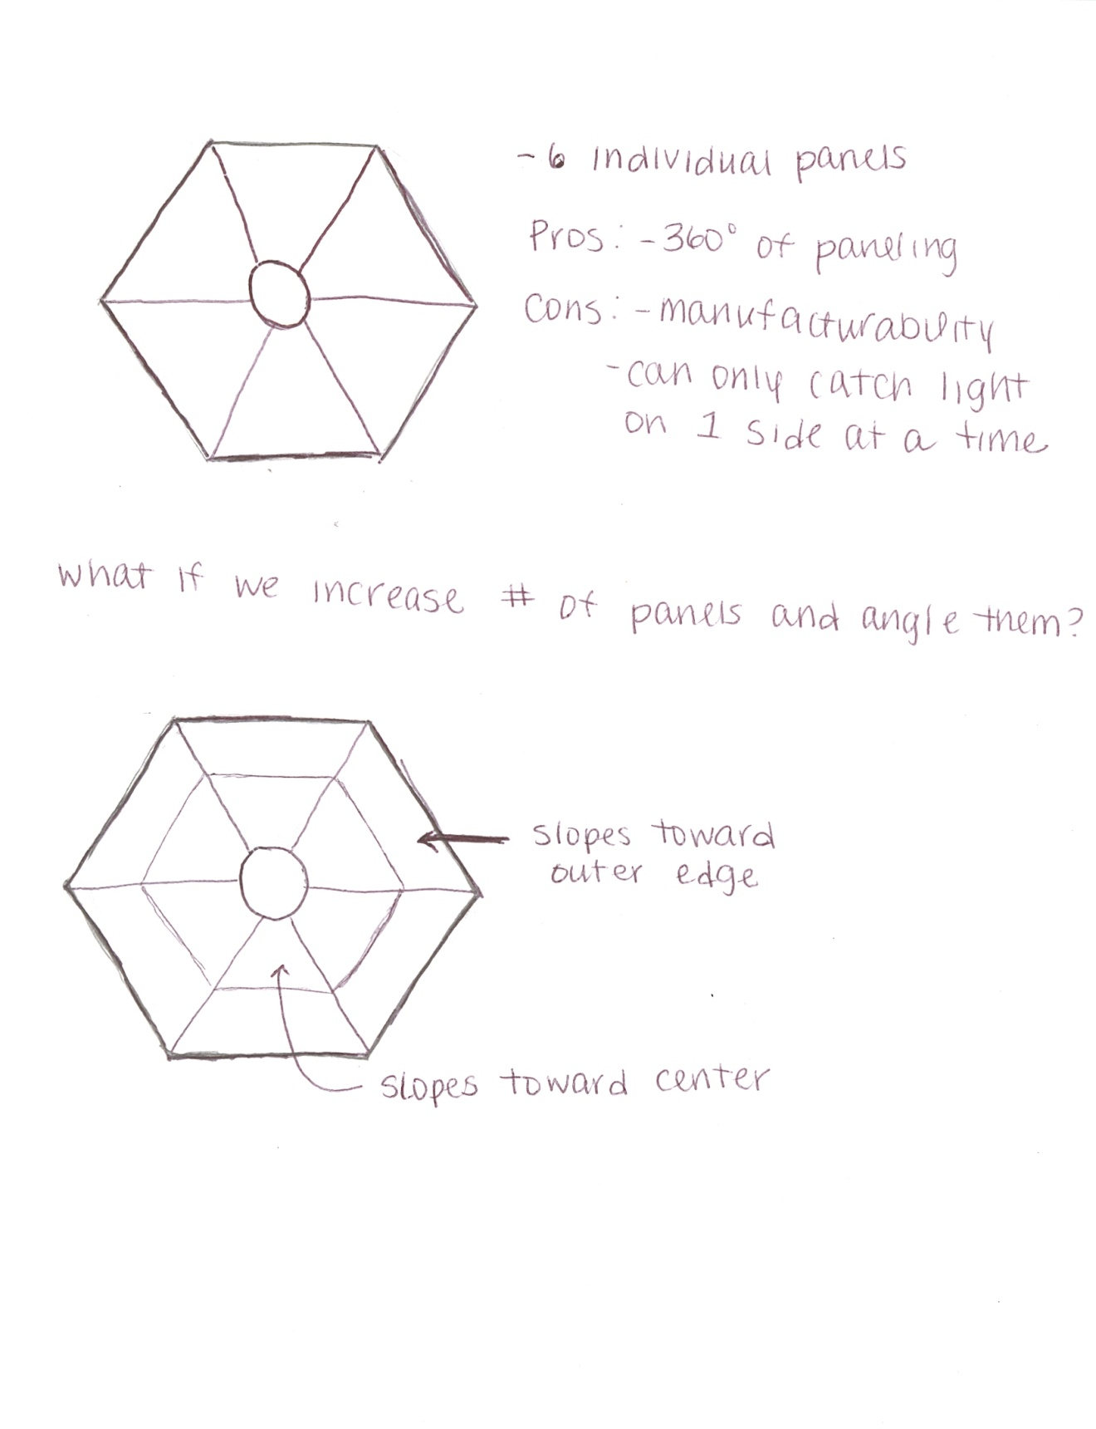

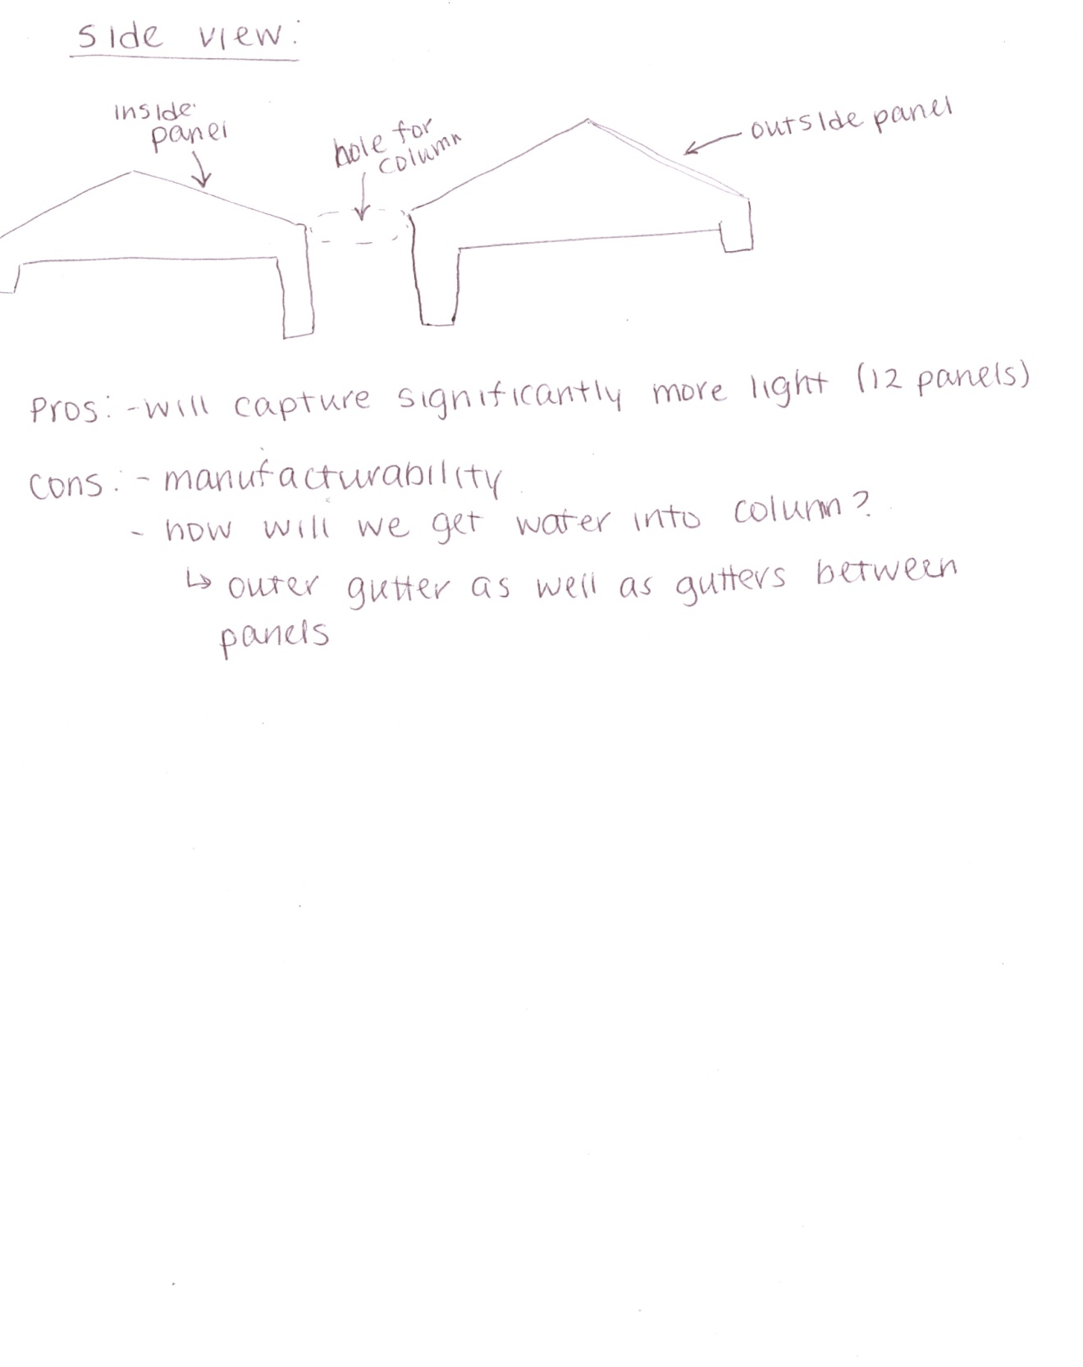

Initial sketches (displayed above) considered both the hexagonal shape as well as the optimum design for the solar panels. The best design considered includes twelve panels, patterned geometrically around the hexagon, with two in each of the six segments. The inner panel will be angled toward the center at an angle of 25˚ from the horizontal, and the outer panel will be angled 25˚ as well, but toward the outer edge of the cap.

Rainwater collection was also a major consideration in the cap design. A gutter could easily be added to the outer edge to collect water, but the problem of getting that water to the water storage and filtration system forced the change of the current sketches.

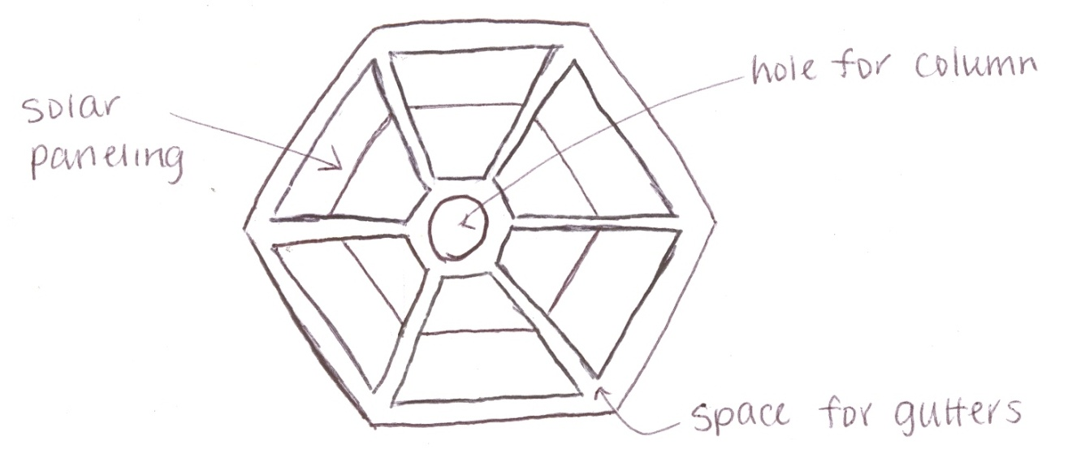

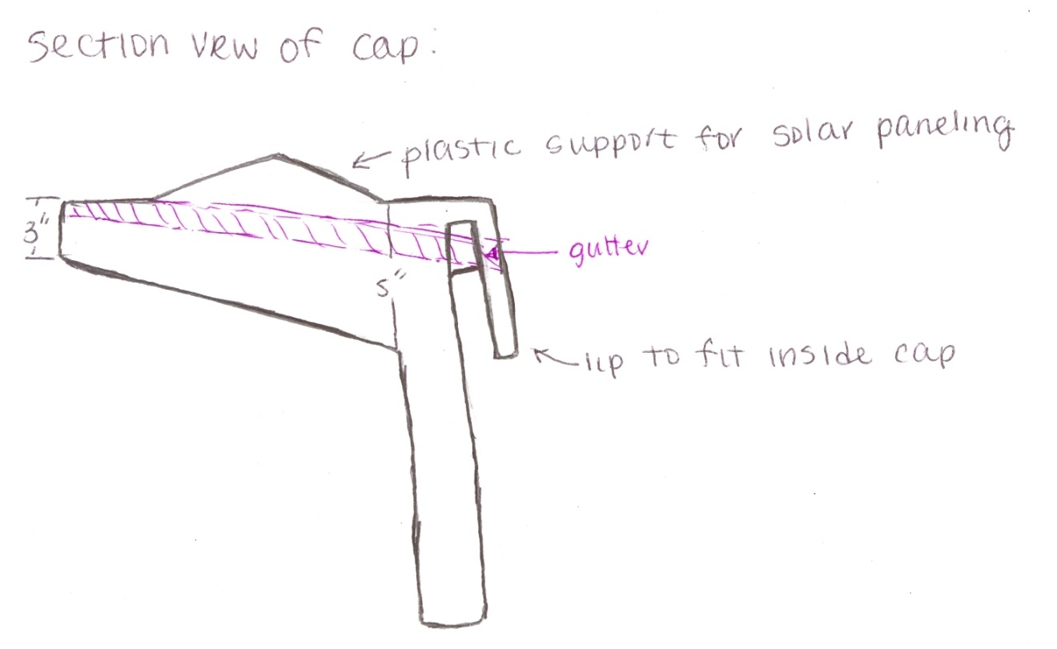

A solution to this problem was to add space between the sections of solar panels in which smaller gutters could be added to connect the outer gutter with the central column. These smaller gutters will be one inch wide and three quarters of an inch deep.

The major dimensions of the cap could not be determined until the dimensions of the individual solar panels were calculated.

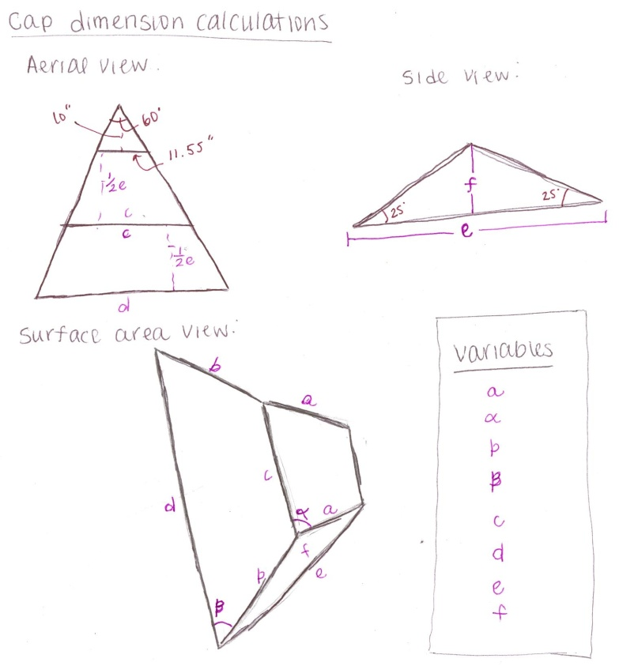

## Geometric Equations

Required surface area:

#1.) X = ½*h*(d1+d2) = ½*(a*sin(α))*(11.55+c)

Where: X = area of trapezoid with large base c and height a*sin(α)

#2.) Y = ½*h*(d1+d2) = ½*(b*sin(β))*(c+d)

Where: Y = area of trapezoid with large base d and height b*sin(β)

#3.) Total area = X+Y

Cross-section:

#4.) a*sin(α) = b*sin(β)

#5.) e = 2*(a*sin(α))*cos(25°)

Aerial view:

#6.) 11.55/10 = c/(10 + ½*e) = d/(10 + e)

So:

a.) 10*c = 11.55*(10 + ½*e)

b.) 10*d = 11.55*(10 + e)

## Calculations

Using the equations for similar triangles, right triangles, and trapezoid geometry, we determined the dimensions of each panel based on an overall physical area of 378 sq. in. and an aerial shape of an equilateral triangle. First the cross-section equation for e (#5) was plugged into the aerial view equations for c and d (#6a and #6b). Then, those new equations were plugged into the total area equation (#3), into which X and Y (#1 and #2) were plugged in. From there, we were able to solve for a*sin(α). We then took the value for that and plugged it in to solve for the remaining variables.

## Dimensions

|  |  |  |
| --- | --- | --- |
| Variable | Length | Unit |
| a*sin(α) | 9.01 | Inches |
| c | 20.98 | Inches |
| d | 30.41 | Inches |
| e | 16.33 | Inches |
| f | 3.69 | inches |

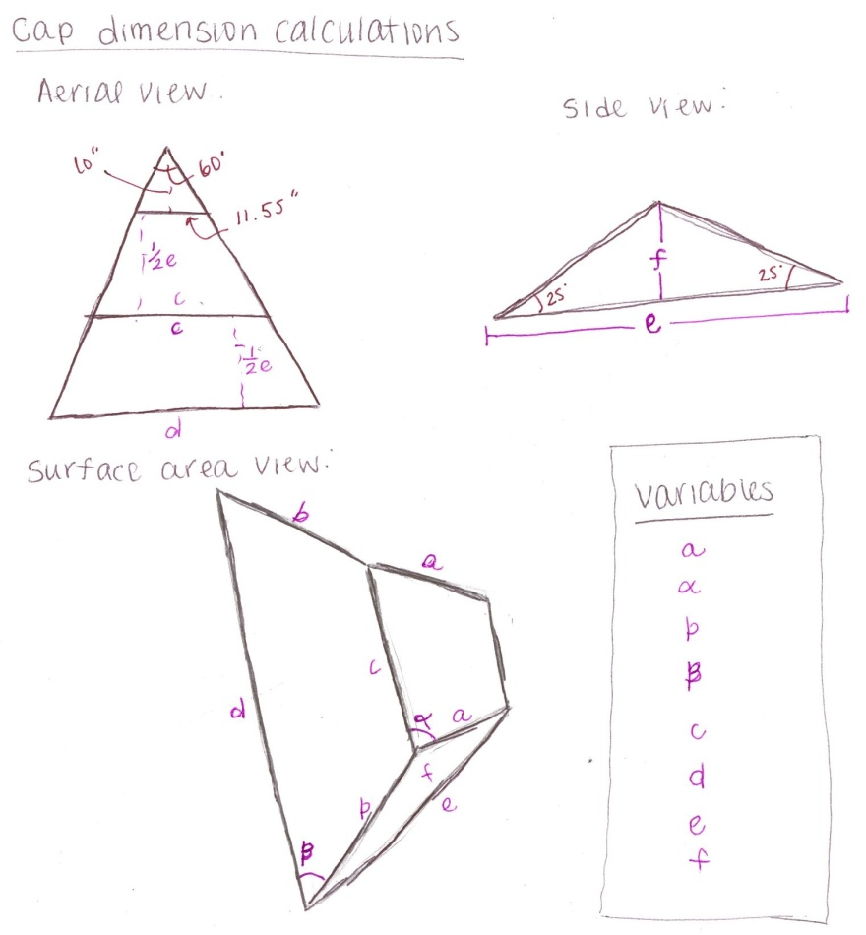

Once basic dimensioning was completed, the model was built in SolidWorks™ to find final lengths as well as to better conceptualize the design. The column, lights and solar panels were also built as parts and the entire assembly was put together.

## Design Iterations

The solar panels selected for use in the HOME in the original design were trapezoidal in shape to maximize space on the hexagonal cap of the structure. After concerns from the client, and a request to consider more standard and easily accessible parts, the panel and cap designs were reconsidered. The first part of this process included choosing requirements and researching rectangular panels. Requirements were chosen based on both physical size and available power output. To find the total output needed, the original expected eight hundred Watt-hours over three days was divided by three to find the needed power production per day. This number, 266.67 Watt-hours/day was then divided by an assumed sun availability of five hours per day, resulting in 53.33 Watts. This being an ideal value, an efficiency of 65% was assumed, providing the need for an actual availability of at least 75 Watts in paneling. After sketching and brainstorming, it was determined that 18 identical panels would be used on the hexagon cap, with each of the six sections holding three panels, two toward the outer edge and one declined toward the center of the cap. Research on individual panels, completed through a tradeoff study, proved that SolarLand 5 Watt 12 Volt panels would work best for our use. Using eighteen of these panels would cost $630, weigh 29.7 lbs, and provide 90 nominal Watts of power to the HOME.

|  |  |  |  |  |  |  |  |
| --- | --- | --- | --- | --- | --- | --- | --- |
| solarpanelstore.com | 12V | | | | | | |
|  | | | | | | | |
| Part Name | Part No. | Length | Width | Depth | Power | Cost | Weight |
|  | | | | | | | |
| Suntech STP005S-12 | COLO-00288 | 12 in | 8.5 in | 0.75 in | 5 W | $52.00 | unknown |
| [Solarland 5W 12V](http://www.solarpanelstore.com/solar-power.small-solar-panels.smallspssolarcollectors.solarland5.info.1.html) | COLO-00015 | 10.63 in | 8.74 in | 0.34 in | 5 W | $35.00 | 1.65 lbs |
| [Suntech 10 Watt](http://www.solarpanelstore.com/solar-power.small-solar-panels.smallspssolarcollectors.stp010-12.info.1.html) | COLO-00324 | 14.5 in | 12.2 in | 0.7 in | 10 W | $88.50 | 3.3lbs |
| [SolarLand 10W 12V](http://www.solarpanelstore.com/solar-power.small-solar-panels.smallspssolarcollectors.solarland10.info.1.html) | COLO-00542 | 14.06 in | 11.89 in | 1.18 in | 10 W | $56.00 | 3.53 lbs |
| SolarLand 20W 12V | COLO-00802 | 22.68 in | 14.06 in | 1.18 in | 20 W | $140.00 | 6.17 lbs |

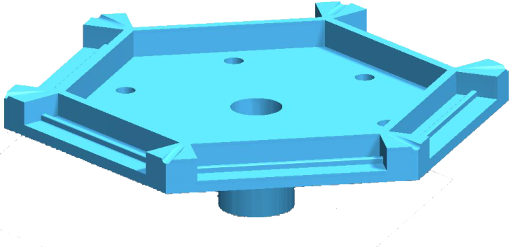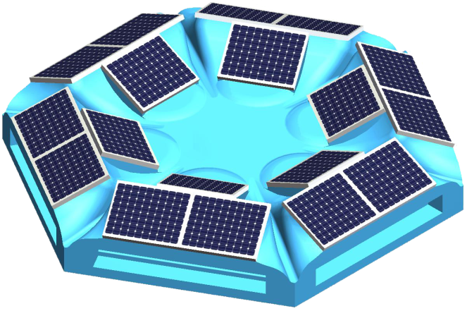***Table 11:*** *Specifications for five models of rectangular solar panels. This information was found when researching new panels for the redesign of the power cap. Note that the highlighted row signifies the selected model.*

The design of the power cap was rebuilt in SolidWorks to reflect the new rectangular solar panels as well as the possibility of a column which is much smaller in thickness. This re-design incorporates the new panels as well as a more detailed method of ensuring all water that falls on the cap flows directly off. It also includes the new interfaces for the column and roof panels.

***Figure 17 :*** *Solidworks renderings of the cap assembly (left) and the bottom portion of the cap (right). The bottom portion of the cap reflects the interface for the roof panels along the edges, space for wiring, and holes for the recessed lighting.*

# Conclusion

The Human Occupied Modular Environment project is motivated by four major requirements: ease of use, durability, human factors, and commercial viability. The project poses a variety of logistical and design challenges, and much work remains to be done. However, the design set forth for all subsystems, including the water filtration and storage systems and the power and electrical systems, satisfies all of the major design requirements.

The design goal of rapid and intuitive installation and maintenance is an important influence in each subsystem. The rainwater collection system functions without any human input and requires minimal maintenance. The polycrystalline solar panels require nothing more than cleaning, and the human power mechanism is intuitive and easy to use. All systems are already installed, and require only the assembly of the structure in order for the systems to function properly. Furthermore, all structures that house the subsystems will be within reasonable weight limits for transport and assembly.

The subsystems are also designed to maximize longevity and protection from the elements. Polycrystalline solar panels were selected because of their higher durability in comparison to monocrystalline panels. Settling volume in the water storage tank allows the tank to be used for years without a decrease in water quality. The power cap was designed to provide protection from the rain and wind, and will aid in distributing the load across the structure. The central column provides structural support and will withstand expected loads for the lifespan of the shelter.

Human factors are also well accounted for by the systems designed. The water filtration system eliminates debris and most contaminants, and water will be stored in isolation from sunlight. As a result, water that passes through the filtration system will be clean and potable. The solar and human power systems, taken together with the lighting and electrical systems, provide enough power for twelve hours of LED lighting and the use of a 100W outlet for five hours. All candidates for battery selection are non-toxic, and no glass will be used in the interior of the structure, so as to avoid potential safety hazards.

Finally, the designs proposed promote the viability of the structure as a commercial product. The use of solar panels is limited in order to reduce manufacturing expense. The amount of power storage was reduced considerably, which also reduces costs. No expensive and complex water filters are used; instead, the water system improves collection practices to ensure cleaner water. Also, renewable power sources are an appealing option in today’s marketplace, and the use of solar and human power improves the marketability of the product.

This project presents a number of interesting challenges. A major challenge is the complexity of the design as a whole. There are numerous subsystems, many of which are not yet designed, but all of which impact one another. The design requirements are varied and often conflicting, and numerous tradeoff studies were required to reconcile competing goals, such as maximizing power efficiency while minimizing cost.

# Team Collaboration

Working with multiple teams and an external client proved to be both challenging and difficult. The first semester of this project was spent learning and researching the project, but was also spent feeling out one another’s strengths, weaknesses, and working styles. The pressure of preparing for the first semester’s presentation, as well as completing the binders and papers while also accounting for final exams put a lot of stress on our team. We may not have necessarily gone about things in the *best* manner and tensions ran high at times, but we produced a polished product which we were proud of. At the end of the semester, we sat down as a team and discussed what did and did not work in terms of communication and scheduling. We made changes accordingly, and credit much of our success to our consideration for one another.

Unfortunately one of our teammates, Anthony DeSousa, was unable to return for the second semester. Anthony had been focusing much of his efforts on the water filtration portion of the project; we needed to reassign tasks for the duration of the design. As a result, each member of the team was forced to take on larger portion of the design. Henry, who is a computer scientist rather than civil engineer, stepped up and completed an extensive amount of research for our water collection, filtration, and storage methods.

Working with a team at another university, particularly on such an integrated design, proved quite challenging. Communicating constantly changing designs and dimensions caused frustrations in both teams as well as problems such as having to re-work the same part or interface multiple times. At a few points, relations between the two teams were strained due to differences in expectations. The other team made changes to the agreed-upon designs and dimensions without communicating these changes to our team. Later, they raised objections to our designs based on their new dimensions, which caused temporary conflict. Upon realizing the errors, our team attempted to resolve the issues and updated our designs accordingly.

# Lessons Learned

Our team learned a variety of lessons throughout the course of this project. We spent a great deal of time reviewing the requirements provided to us by our client, and then narrowing them down to a list which reflected the original requirements, but were also realistic to complete. From there, we learned to research innovative methods and to think outside the box.

The largest lessons learned were in communication and documentation of designs. Communication was a key factor in our project, between communicating with one another, with our counterpart team at URI, communicating all design decisions to our client, and through our presentations. We were forced to communicate our highly intricate project to people of a large spectrum of technical backgrounds.

Our team finds that this was an extremely beneficial project, both in the lessons it has taught us and in the overall purpose of the HOME. If it were presented again in its beginning phase, we would recommend that it be completed again next year. However, at the current stage of the project, we would only recommend this project be used by a program with a focus on manufacturing and industrial engineering.